Chapter 5

Analysis of Variance

The purpose of Analysis of Variance (ANOVA) is to determine whether or not there is a difference between two or more means. This purpose can also be stated in terms of the relationship between the independent and dependent variables. In this latter context, if there is a difference between the means of a treatment and control then there is said to be a relationship between independent and dependent variables.

Assumptions of parametric statistical tests (and consequently ANOVA) are that:

1. That the data are normally distributed.
2. That the variances of the populations from which the data are drawn are equal. This is referred to as homogeniety or homoscedasticity.
3. That the sample is randomly drawn from the population.

The one-way analysis of variance is the appropriate test when there is a single independent variable, a single dependent variable and two or more groups.

If the test is significant then post hoc need to be computed to determine which of the means were different. However, if planned comparisons are computed then the post hoc tests are not necessary.

The following set of data has three has had (1) no hospitalizations, (2) one hospitalization or (3) 2 or more hospitalizations. The dependent measure is degree of depression as measured by the Fake Diagnostic Scale. The data file is: dataDiag-SpringFall.sav. The following procedure with run a one-way ANOVA on the fake data. Open the data file in spss.

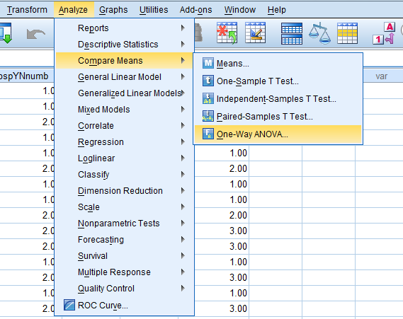

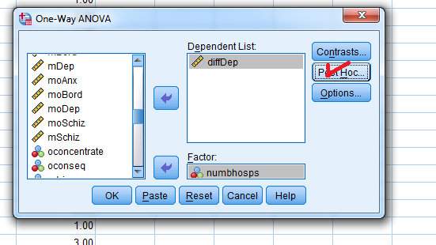

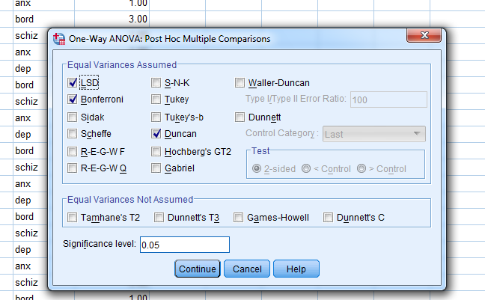

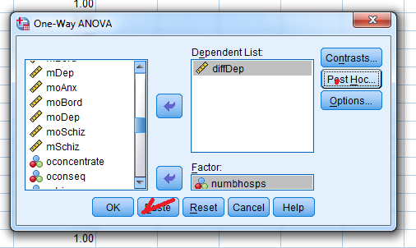

ONEWAY diffDep BY numbhosps
/MISSING ANALYSIS
/POSTHOC=DUNCAN LSD BONFERRONI ALPHA(0.05).

ANOVA
diffDep
 | Sum of Squares | df | Mean Square | F | Sig.
Between Groups | 5.942 | 2 | 2.971 | 2.699 | .071
Within Groups | 127.681 | 116 | 1.101
Total | 133.623 | 118

The ANOVA is not significant and therefore there is no significant difference between those who had 0 hospitalizations, 1 hospitalization or 2 or more hospitalization on the change score of depression. The change score was calculated by subtracting the posthospitalization score on depression from the prehospitalization score for each patient.

ONEWAY mDep BY numbhosps
/MISSING ANALYSIS
/POSTHOC=DUNCAN LSD BONFERRONI ALPHA(0.05).

In this next run the score on the depression scale was used when the patient was first admitted (the pretest).

ANOVA
mDep
 | Sum of Squares | df | Mean Square | F | Sig.
Between Groups | 8.598 | 2 | 4.299 | 3.278 | .041
Within Groups | 152.143 | 116 | 1.312
Total | 160.741 | 118

In this instance the ANOVA was statistically significant indicting that there was a difference between at least two of the groups (group 1 = no previous hospitalizations; group 2 = 1 previous hospitalization; or group 3 = 2 or more hospitalizations. The question remains where were the differences among the groups? Were they all different or was just a pair different? It it was a pair then which pair? The post-hoc test can give that information.
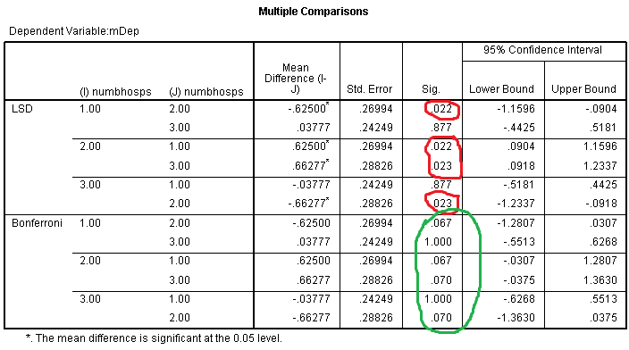
We see that according to the LSD test the there were differences between groups 1 and 2; between and 2 and 3 but no difference between 1 and 3. The Bonferroni indicates no differences among and of the groups.

Let’s try comparing those the groups on the schizophrenia subscale.

ONEWAY mSchiz BY numbhosps
/MISSING ANALYSIS
/POSTHOC=DUNCAN LSD BONFERRONI ALPHA(0.05).

ANOVA
mSchiz
 | Sum of Squares | df | Mean Square | F | Sig.
Between Groups | 18.095 | 2 | 9.047 | 6.097 | .003
Within Groups | 172.146 | 116 | 1.484
Total | 190.241 | 118

There is a significant difference somewhere among the groups.

