Chapter 11

Factor Analysis

Merle Canfield, Ph.D.

Factor analysis takes a set of correlations and finds a solution such that variables that are correlated together form a factor that is not related to other factors. It summarizes the correlation matrix. It can be thought of as reducing the redundancy in a set of correlations. It is assumed that there is an underlying factor or variable that results in the variables being related. From a theoretical point of view this is the epitome of taking advantage of chance correlations. The variables are the manifestations of the underlying factor or variable.

There five general uses of factor analysis as presented here: (1) summarizing data of a correlation matrix, (2) reducing data, (3) constructing tests, (3) building theory (identifying underlying factors), (4) generating Y' for each factor, and (5) selecting a smaller set of variables from a large set. Some scientists believe that this type of factor analysis can also be used for theory testing ‑‑ it is not presented as such here.

There may be more problems than advantages: (1) factor naming borders on fiction writing, (2) there is no outside criterion with which to compare the solution, (3) there are an infinite number of solutions of the rotation, (4) there is hardly ever a clear solution of factors ‑‑ there is almost always an overlap of variables, (5) like finding a mean, a solution can almost always be found even when the data are random garbage ‑‑ in combination with the above problems it can become a nightmare.

There are basically four things to do with the print‑out in exploratory factor analysis: (1) determine the number of factors (see the methods below), (2) check the communalities of the variables, (3) identify the variables that make up the factors by noting their correlations with the factors (sort of treating the output like a set of Rorschach cards), and (4) generate Y' for each factor from the factor scores.

There are a number of ways to determine the number of factors ‑‑ here are four of them: (1) theory ‑‑ when the factors make sense (my preferred method, since it is exploratory), (2) eigenvalue greater than one (highly criticized but still used), (3) the scree plot, and (4) successive fits in relation to reproduced correlation matrix (when the residual matrix is small).

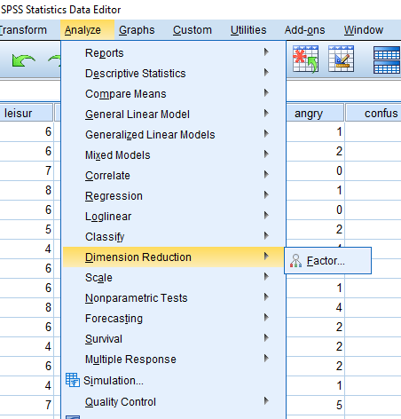

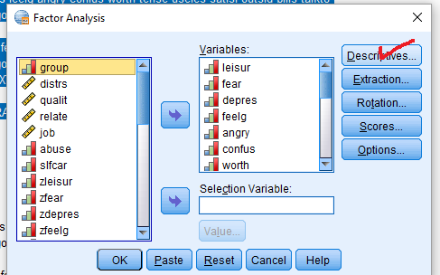

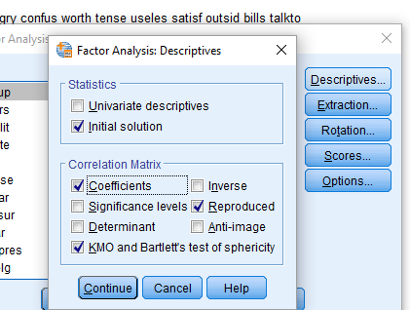

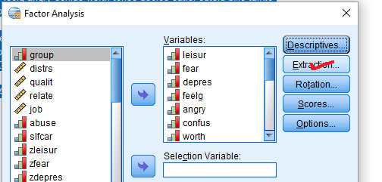

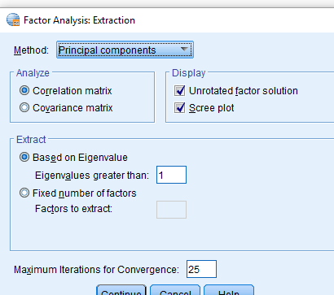

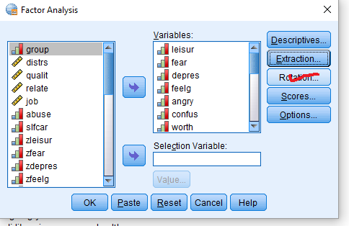

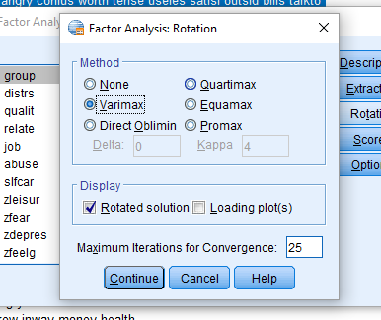

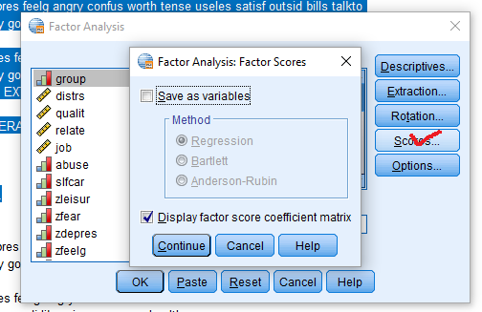

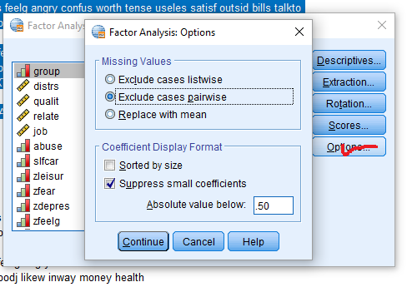

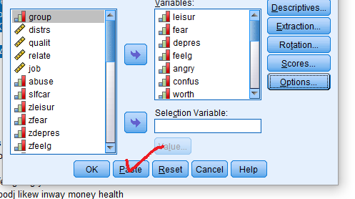

|  |
| --- |
| File Name = crsfac2s2016.sps |
| get file = '\rdda\crsleq9.sav'.  FACTOR  /VARIABLES leisur fear depres feelg angry confus worth tense useles satisf outsid bills talkto  conflt alcdrg supprt employ goodj likew inway money health  /MISSING PAIRWISE  /ANALYSIS leisur fear depres feelg angry confus worth tense useles satisf outsid bills talkto  conflt alcdrg supprt employ goodj likew inway money health  /PRINT INITIAL CORRELATION KMO REPR EXTRACTION ROTATION FSCORE  /PLOT EIGEN  /CRITERIA MINEIGEN(1) ITERATE(25)  /EXTRACTION PC  /CRITERIA ITERATE(25)  /ROTATION VARIMAX  /METHOD=CORRELATION. |

‑ ‑ ‑ ‑ ‑ ‑ ‑ ‑ ‑ ‑ ‑ F A C T O R A N A L Y S I S ‑ ‑ ‑ ‑ ‑ ‑ ‑ ‑ ‑ ‑ ‑

Analysis number 1 Pairwise deletion of cases with missing values

Extraction 1 for analysis 1, Principal Components Analysis (PC)

Initial Statistics:

Variable Communality * Factor Eigenvalue Pct of Var Cum Pct

*

LEISUR 1.00000 * 1 6.39831 29.1 29.1

FEAR 1.00000 * 2 2.91594 13.3 42.3

DEPRES 1.00000 * 3 1.74551 7.9 50.3

FEELG 1.00000 * 4 1.47050 6.7 57.0

ANGRY 1.00000 * 5 1.12909 5.1 62.1

CONFUS 1.00000 * 6 .95818 4.4 66.4

WORTH 1.00000 * 7 .93068 4.2 70.7

TENSE 1.00000 * 8 .81755 3.7 74.4

USELES 1.00000 * 9 .73070 3.3 77.7

SATISF 1.00000 * 10 .63359 2.9 80.6

OUTSID 1.00000 * 11 .60616 2.8 83.3

BILLS 1.00000 * 12 .55287 2.5 85.9

TALKTO 1.00000 * 13 .49314 2.2 88.1

CONFLT 1.00000 * 14 .46944 2.1 90.2

ALCDRG 1.00000 * 15 .35873 1.6 91.9

SUPPRT 1.00000 * 16 .34820 1.6 93.4

EMPLOY 1.00000 * 17 .32030 1.5 94.9

GOODJ 1.00000 * 18 .27831 1.3 96.2

LIKEW 1.00000 * 19 .24974 1.1 97.3

INWAY 1.00000 * 20 .23058 1.0 98.4

MONEY 1.00000 * 21 .20175 .9 99.3

HEALTH 1.00000 * 22 .16071 .7 100.0

‑ ‑ ‑ ‑ ‑ ‑ ‑ ‑ ‑ ‑ ‑ F A C T O R A N A L Y S I S ‑ ‑ ‑ ‑ ‑ ‑ ‑ ‑ ‑ ‑ ‑



PC extracted 5 factors.

Factor Matrix:

Factor 1 Factor 2 Factor 3 Factor 4 Factor 5

LEISUR .64017 .28916 .13527 .09660 .15153

FEAR ‑.72575 .28042 ‑.17297 .04314 .18362

DEPRES ‑.72814 .47731 .00329 .10990 .10981

FEELG .61353 .12837 .12632 .42441 ‑.18664

ANGRY ‑.55175 .52154 .14969 ‑.00190 ‑.08748

CONFUS ‑.74465 .42434 .01333 .08003 .06106

WORTH .57924 .26633 .12770 .43410 ‑.18833

TENSE ‑.61855 .50509 ‑.04274 .12120 ‑.13715

USELES ‑.68304 .30554 .03710 .27233 .08282

SATISF .66285 .10115 .16790 .37301 ‑.19010

OUTSID .40083 .18315 .66723 ‑.05772 .19063

BILLS .37296 .38660 .01337 ‑.40623 ‑.29303

TALKTO .61918 .27989 .33144 ‑.07669 .30926

CONFLT ‑.34482 .17987 .34568 ‑.48794 ‑.08299

ALCDRG .00968 .23455 .60549 ‑.19982 ‑.32701

SUPPRT .52783 .21750 ‑.03208 ‑.28357 .56861

EMPLOY .33911 .41302 ‑.27791 ‑.44803 ‑.26231

GOODJ .45439 .54966 ‑.36123 ‑.21672 .00656

LIKEW .44541 .45826 ‑.31410 .08291 ‑.12681

INWAY ‑.45178 .38806 .32496 .14648 .00934

MONEY .38116 .44731 ‑.38028 .10706 ‑.11568

HEALTH .34959 .44529 ‑.10990 .15525 .40433

Final Statistics:

Variable Communality * Factor Eigenvalue Pct of Var Cum Pct

*

LEISUR .54402 * 1 6.39831 29.1 29.1

FEAR .67085 * 2 2.91594 13.3 42.3

DEPRES .78216 * 3 1.74551 7.9 50.3

FEELG .62382 * 4 1.47050 6.7 57.0

ANGRY .60650 * 5 1.12909 5.1 62.1

CONFUS .74488 *

WORTH .64667 *

TENSE .67305 *

USELES .64230 *

‑ ‑ ‑ ‑ ‑ ‑ ‑ ‑ ‑ ‑ ‑ F A C T O R A N A L Y S I S ‑ ‑ ‑ ‑ ‑ ‑ ‑ ‑ ‑ ‑ ‑

Variable Communality * Factor Eigenvalue Pct of Var Cum Pct

SATISF .65307 *

OUTSID .67907 *

BILLS .53963 *

TALKTO .67310 *

CONFLT .51572 *

ALCDRG .56859 *

SUPPRT .73067 *

EMPLOY .63235 *

GOODJ .68609 *

LIKEW .53001 *

INWAY .48184 *

MONEY .51483 *

HEALTH .52015 *

The communalities are the sum of the squared loadings from the factor matrix. For LEISUR the communality is:

LEISUR = .640172 + .289162 + .135272 + .096602 + .151532

LEISUR = .4098 + .0836 + .0183 + .00933 + .0230 = .54403

In the output you can see that the communality for LEISUR is .54403. The mean of the communalities is the proportion of variance accounted for by the factors. The total variance accounted for can be calculated by adding the communalities and dividing by the number of variables. The calculation is not shown but it is .621. This proportion is comparable to the 62.1% indicated in the output under Cum Pct. The eigenvalue is the sum of the squared factor loadings (before rotation).

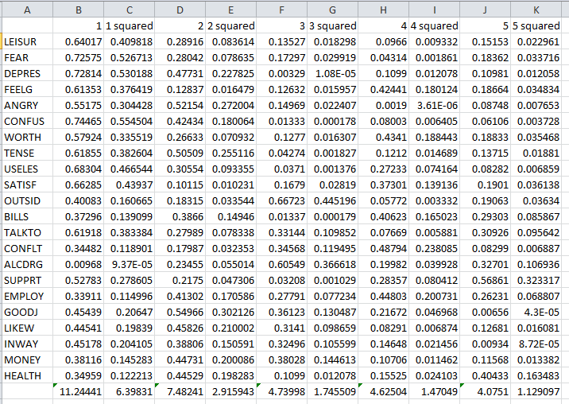

As noted in the introduction there are four methods of determining the number of factors. Three of those methods are discussed here. The first of these is to use the eigenvalue to determine the number of factors. This method was used by the computer program to select to five factors. The default of the program was to select factors with eigenvalues greater than 1.0. Consequently, the program completed the analysis indicating five factors.

Another method to assess the number of factors is to utilize the scree test. When using this method the eigenvalues and the number of factors are plotted (see page 3) and then the point on the graph that contains the largest bend (or smallest angle), or elbow is found. The lines drawn on the plot help determine the elbow. The number of factors at the elbow is the number of factors selected. According to my judgement the elbow is at six factors. This indicates a different number of factors would be selected using the methods of eigenvalues and the scree test. There were five selected by the eigenvalue method and six selected using the scree test.

The next method used to estimate the number of factors is the residual of the Reproduced Matrix. The reproduced correlation matrix can be thought of as Y'. The reproduced matrix is much the same as the regression line in regression analysis. In regression analysis the difference between the regression line and the actual data is the residual. In much the same way the difference between the reproduced matrix and the actual correlation matrix is the residual matrix. The residual correlation matrix is the difference between the reproduced correlation matrix and the actual correlation matrixes. If the residual is great then it is probable that more factors exist. The reproduced and residual matrix follow. The SPSS program presents the reproduced matrix and the residual matrix as a single matrix. The reproduced matrix is below the diagonal (the diagonal is identified by the asterisks) and the residual is above the diagonal.

Partial of original correlation matrix.

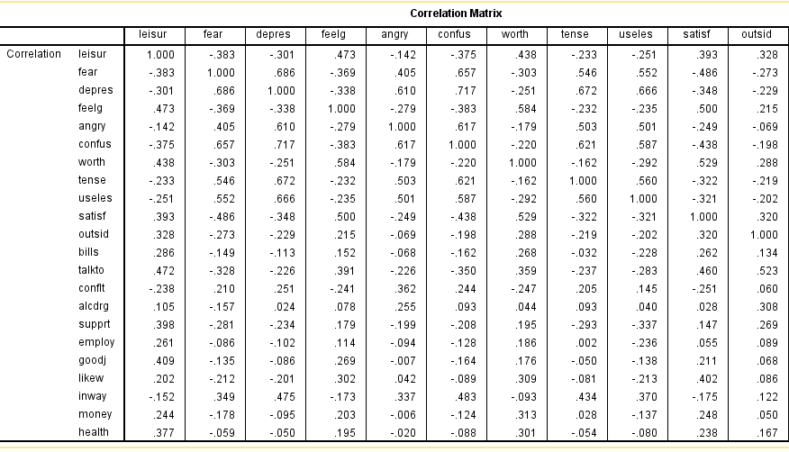

The reproduced correlations are below the diagonal and the error above. The reproduced matrix is generated but Y’ for each person using the factor scores above.

Reproduced Correlation Matrix:

LEISUR FEAR DEPRES FEELG ANGRY

LEISUR .54402* ‑.00782 ‑.00077 .01341 .05405

FEAR ‑.37492 .67085* ‑.00030 .07773 ‑.10014

DEPRES ‑.30041 .68663 .78216* .02137 ‑.03101

FEELG .45969 ‑.44708 ‑.35890 .62382* ‑.04192

ANGRY ‑.19559 .50465 .64136 ‑.23713 .60650*

CONFUS ‑.33521 .67179 .76030 ‑.37814 .62867

WORTH .47849 ‑.38364 ‑.26720 .62509 ‑.14593

TENSE ‑.26478 .57799 .68959 ‑.24302 .61008

USELES ‑.30504 .60194 .68233 ‑.27503 .53401

SATISF .48352 ‑.50056 ‑.41370 .63466 ‑.27192

OUTSID .42313 ‑.32244 ‑.18765 .29364 ‑.04233

BILLS .26871 ‑.23591 ‑.16382 .16242 .02426

TALKTO .56160 ‑.37474 ‑.29063 .36742 ‑.17295

CONFLT ‑.18168 .20461 .27533 ‑.33640 .34400

ALCDRG .08707 ‑.11465 .04902 .08876 .23660

SUPPRT .45522 ‑.22436 ‑.24935 .12123 ‑.23179

EMPLOY .21590 ‑.14971 ‑.12874 .08478 .01050

GOODJ .38102 ‑.12130 ‑.09278 .21051 ‑.01827

LIKEW .36395 ‑.16013 ‑.11143 .35128 ‑.04283

INWAY ‑.11748 .38852 .53237 ‑.12589 .49920

MONEY .31472 ‑.10203 ‑.06622 .31027 ‑.02402

HEALTH .41395 ‑.02890 .01909 .24819 ‑.01276

CONFUS WORTH TENSE USELES SATISF

LEISUR ‑.03951 ‑.04084 .03204 .05399 ‑.09062

‑ ‑ ‑ ‑ ‑ ‑ ‑ ‑ ‑ ‑ ‑ F A C T O R A N A L Y S I S ‑ ‑ ‑ ‑ ‑ ‑ ‑ ‑ ‑ ‑ ‑

CONFUS WORTH TENSE USELES SATISF

FEAR ‑.01451 .08071 ‑.03204 ‑.04973 .01502

DEPRES ‑.04350 .01610 ‑.01789 ‑.01655 .06542

FEELG ‑.00497 ‑.04148 .01148 .03959 ‑.13432

ANGRY ‑.01211 ‑.03288 ‑.10691 ‑.03317 .02335

CONFUS .74488* .07308 ‑.05516 ‑.07898 ‑.00776

WORTH ‑.29337 .64667* ‑.01082 ‑.08542 ‑.10134

TENSE .67569 ‑.15078 .67305* ‑.03657 ‑.02719

USELES .66563 ‑.20691 .59688 .64230* .00866

SATISF ‑.43019 .63005 ‑.29482 ‑.32979 .65307*

OUTSID ‑.20484 .30520 ‑.21709 ‑.19300 .33847

BILLS ‑.16390 .19955 ‑.04505 ‑.27103 .19275

TALKTO ‑.32514 .38399 ‑.30750 ‑.32038 .40699

CONFLT .29359 ‑.30387 .24161 .16355 ‑.31856

ALCDRG .06443 .12024 .10723 .00601 .11943

SUPPRT ‑.28916 .12938 ‑.32761 ‑.32539 .15262

EMPLOY ‑.13284 .12585 ‑.00760 ‑.25948 .10264

GOODJ ‑.12688 .26814 ‑.01516 ‑.21430 .21405

LIKEW ‑.14251 .39981 ‑.00318 ‑.16379 .34389

INWAY .51771 ‑.05501 .47803 .47987 ‑.15279

MONEY ‑.09758 .35961 .03526 ‑.11821 .29597

HEALTH ‑.03572 .29830 ‑.02327 ‑.03104 .23936

OUTSID BILLS TALKTO CONFLT ALCDRG

LEISUR ‑.09550 .01767 ‑.08995 ‑.05613 .01799

FEAR .04984 .08679 .04650 .00580 ‑.04204

DEPRES ‑.04181 .05128 .06454 ‑.02400 ‑.02455

FEELG ‑.07855 ‑.01019 .02317 .09534 ‑.01081

ANGRY ‑.02679 ‑.09272 ‑.05275 .01824 .01811

CONFUS .00723 .00184 ‑.02437 ‑.04959 .02899

WORTH ‑.01725 .06821 ‑.02467 .05680 ‑.07574

TENSE ‑.00162 .01325 .07063 ‑.03640 ‑.01375

USELES ‑.00934 .04255 .03739 ‑.01814 .03384

SATISF ‑.01829 .06886 .05338 .06763 ‑.09189

OUTSID .67907* ‑.06250 ‑.06109 ‑.07734 ‑.09166

BILLS .19681 .53963* .02275 .01195 ‑.16477

TALKTO .58397 .28410 .67310* .00206 ‑.08076

CONFLT .13773 .16809 ‑.03684 .51572* ‑.21630

ALCDRG .40004 .27938 .18652 .37280 .56859*

SUPPRT .35476 .22909 .57466 ‑.06280 ‑.09257

EMPLOY .00200 .54130 .18670 .10167 .10719

GOODJ .05554 .46326 .33412 ‑.07748 ‑.04424

LIKEW .02393 .34256 .25437 ‑.20967 ‑.05349

INWAY .10014 ‑.07637 ‑.07176 .26567 .25108

MONEY ‑.04726 .30042 .19118 ‑.22506 ‑.10521

HEALTH .21647 .11951 .41780 ‑.18775 ‑.12196

‑ ‑ ‑ ‑ ‑ ‑ ‑ ‑ ‑ ‑ ‑ F A C T O R A N A L Y S I S ‑ ‑ ‑ ‑ ‑ ‑ ‑ ‑ ‑ ‑ ‑

SUPPRT EMPLOY GOODJ LIKEW INWAY

LEISUR ‑.05672 .04548 .02828 ‑.16156 ‑.03462

FEAR ‑.05666 .06404 ‑.01395 ‑.05178 ‑.03942

DEPRES .01498 .02681 .00717 ‑.08974 ‑.05706

FEELG .05804 .02908 .05820 ‑.04945 ‑.04759

ANGRY .03301 ‑.10424 .01162 .08488 ‑.16255

CONFUS .08079 .00500 ‑.03664 .05322 ‑.03431

WORTH .06541 .06018 ‑.09260 ‑.09048 ‑.03821

TENSE .03439 .00963 ‑.03448 ‑.07780 ‑.04373

USELES ‑.01187 .02342 .07584 ‑.04953 ‑.11002

SATISF ‑.00583 ‑.04770 ‑.00278 .05850 ‑.02243

OUTSID ‑.08589 .08700 .01232 .06223 .02232

BILLS ‑.04461 ‑.13493 ‑.09140 ‑.12137 ‑.02960

TALKTO ‑.04903 .00476 .00043 ‑.00286 ‑.04704

CONFLT ‑.04265 ‑.15094 ‑.07715 .10735 ‑.03604

ALCDRG .09860 ‑.02217 .07506 ‑.02158 ‑.10515

SUPPRT .73067* ‑.01150 ‑.06330 .04867 ‑.02774

EMPLOY .25564 .63235* ‑.03753 ‑.12263 .10704

GOODJ .43617 .57687 .68609* ‑.04256 .00302

LIKEW .24923 .42372 .54894 .53001* .07141

INWAY ‑.20071 ‑.15131 ‑.14105 ‑.11450 .48184*

MONEY .21454 .40207 .53247 .51775 ‑.10759

HEALTH .47078 .15739 .41231 .35589 .00567

MONEY HEALTH

LEISUR ‑.07053 ‑.03668

FEAR ‑.07562 ‑.03057

DEPRES ‑.02862 ‑.06952

FEELG ‑.10712 ‑.05348

ANGRY .01770 ‑.00718

CONFUS ‑.02686 ‑.05252

WORTH ‑.04691 .00223

TENSE ‑.00749 ‑.03086

USELES ‑.01887 ‑.04896

SATISF ‑.04809 ‑.00184

OUTSID .09746 ‑.04987

BILLS ‑.10613 .09877

TALKTO .00710 ‑.16746

CONFLT .06275 .11376

ALCDRG .06525 .07363

SUPPRT .00238 ‑.14548

EMPLOY ‑.08578 ‑.06075

GOODJ ‑.12418 ‑.05984

LIKEW ‑.03554 ‑.05722

INWAY ‑.00336 .00321

‑ ‑ ‑ ‑ ‑ ‑ ‑ ‑ ‑ ‑ ‑ F A C T O R A N A L Y S I S ‑ ‑ ‑ ‑ ‑ ‑ ‑ ‑ ‑ ‑ ‑

MONEY HEALTH

MONEY .51483* ‑.00802

HEALTH .34407 .52015*

The lower left triangle contains the reproduced correlation matrix; the

diagonal, reproduced communalities; and the upper right triangle residuals

between the observed correlations and the reproduced correlations.

There are 97 (41.0%) residuals (above diagonal) with absolute values > 0.05.

There are 97 (41.0%) residuals (above diagonal) that are > 0.05

The reproduced correlation matrix can be used to determine the number of factors. If the actual matrix is not much different from the reproduced correlation matrix then no more factors are needed. However, if the actual matrix is different from the reproduced correlation matrix then more factors are needed. The question is how much different is different. Tabachnick and Fidell (1989) say "Several moderate residuals (say, .05 to .10) or a few large residuals (say > .10) suggest the presence of another factor" (p. 636). It looks to me like there are more factors here.

Consequently, both the scree test and the reproduced correlation matrix indicate that there are more than five factors, while the eigenvalue method indicates that there are five factors. The next method used to identify the number of factors is interpretability of the factor structure. The Rotated Factor Matrix is used for interpretability. A variable of .60 is said to load a factor ‑‑ these are marked on the printout by check marks (done manually). The factor structure is then scanned for interpretability. The interpretation is up to you. If the interpretation doesn't make sense to you then try adding or deleting a factor and then assessing the new factor structure for interpretation. The interpretation is determined by your theory. It should be remembered that this is exploratory factor analysis and you are searching for the underlying factors that you will test with confirmatory factory analysis. You are at the exploratory or descriptive level of analysis. You are not testing theory ‑‑ you are generating theory.

VARIMAX rotation 1 for extraction 1 in analysis 1 ‑ Kaiser Normalization.

VARIMAX converged in 8 iterations.

Rotated Factor Matrix:

Factor 1 Factor 2 Factor 3 Factor 4 Factor 5

LEISUR ‑.20373 .44057 .23534 .49753 .07410

FEAR .70024 ‑.36192 ‑.07026 ‑.08428 ‑.19360

DEPRES .85664 ‑.20974 ‑.04572 ‑.04254 ‑.02103

FEELG ‑.22569 .73830 .11217 .12185 .01906

ANGRY .72939 ‑.10369 .07609 ‑.07280 .22944

CONFUS .82189 ‑.23522 ‑.06025 ‑.10171 .00864

WORTH ‑.10764 .76014 .17883 .15410 .03929

TENSE .78356 ‑.07347 .10739 ‑.20229 .03505

USELES .75596 ‑.08895 ‑.20688 ‑.11445 ‑.08369

SATISF ‑.28965 .72821 .11357 .14385 .07271

OUTSID ‑.11797 .27901 ‑.13013 .53764 .53040

BILLS ‑.12962 .06371 .61115 .08623 .37126

TALKTO ‑.22089 .29043 .14186 .67719 .24747

CONFLT .23811 ‑.40072 .03801 ‑.01195 .54485

ALCDRG .10834 .13410 .02336 ‑.01966 .73344

SUPPRT ‑.26022 ‑.07924 .25685 .76615 ‑.06094

EMPLOY ‑.11523 ‑.04834 .76992 .04324 .14864

GOODJ ‑.02716 .11335 .75268 .31209 ‑.09264

LIKEW ‑.00584 .36309 .59347 .14972 ‑.15335

INWAY .62915 .03398 ‑.14965 .02518 .24863

MONEY .03459 .32926 .58512 .11182 ‑.22441

HEALTH .11883 .24491 .24769 .57954 ‑.22097

‑ ‑ ‑ ‑ ‑ ‑ ‑ ‑ ‑ ‑ ‑ F A C T O R A N A L Y S I S ‑ ‑ ‑ ‑ ‑ ‑ ‑ ‑ ‑ ‑ ‑

Factor Transformation Matrix:

Factor 1 Factor 2 Factor 3 Factor 4 Factor 5

Factor 1 ‑.68846 .50289 .34249 .39409 .02260

Factor 2 .66556 .22494 .59779 .34637 .17059

Factor 3 .05869 .20689 ‑.50701 .23318 .80145

Factor 4 .27410 .74769 ‑.40353 ‑.09937 ‑.43945

Factor 5 .06687 ‑.30767 ‑.32473 .81270 ‑.36735

Factor Score Coefficient Matrix:

Factor 1 Factor 2 Factor 3 Factor 4 Factor 5

LEISUR .02865 .09648 ‑.01583 .19438 .00312

FEAR .15520 ‑.08401 .00424 .09475 ‑.13821

DEPRES .21439 .00594 ‑.00382 .08390 ‑.04171

FEELG .03559 .33975 ‑.04032 ‑.09311 .00157

ANGRY .17791 .03748 .05959 ‑.01488 .12632

CONFUS .19596 ‑.00016 .00374 .04486 ‑.01547

WORTH .07252 .35325 ‑.01645 ‑.08052 .00780

TENSE .19488 .08428 .08904 ‑.09072 .01614

USELES .20015 .09018 ‑.08325 .04039 ‑.07584

SATISF .01568 .32126 ‑.04024 ‑.08676 .03572

OUTSID .02164 .04342 ‑.17379 .27669 .27372

BILLS ‑.04452 ‑.06598 .29109 ‑.11279 .24681

TALKTO .01243 ‑.01372 ‑.07364 .34344 .09304

CONFLT ‑.00608 ‑.19773 .07578 .01954 .34085

ALCDRG .01624 .07813 .02161 ‑.11253 .45788

SUPPRT ‑.02741 ‑.24466 ‑.00355 .48250 ‑.10039

EMPLOY ‑.05061 ‑.13075 .38194 ‑.12571 .11699

GOODJ .02441 ‑.07668 .29952 .06439 ‑.06947

LIKEW .05405 .10984 .22274 ‑.05697 ‑.09936

INWAY .17597 .10488 ‑.08190 .05850 .12350

MONEY .06140 .10535 .22646 ‑.06469 ‑.14145

HEALTH .11321 .01757 ‑.01697 .34028 ‑.20112

‑ ‑ ‑ ‑ ‑ ‑ ‑ ‑ ‑ ‑ ‑ F A C T O R A N A L Y S I S ‑ ‑ ‑ ‑ ‑ ‑ ‑ ‑ ‑ ‑ ‑

Covariance Matrix for Estimated Regression Factor Scores:

Factor 1 Factor 2 Factor 3 Factor 4 Factor 5

Factor 1 1.00000

Factor 2 .00000 1.00000

Factor 3 .00000 .00000 1.00000

Factor 4 .00000 .00000 .00000 1.00000

Factor 5 .00000 .00000 .00000 .00000 1.00000

This next analysis was computed because the reproduced correlation matrix, the scree test, and the interpretability of the Rotated Factor Matrix all indicated that there may be more factors. Much of the printout has been deleted to save space.

|  |
| --- |
| File Name = crsfac3.sps |
| get file = '\rdda\crsleq9.sav'.  MISSING VALUES GROUP TO HEALTH (9).  FACTOR VAR = LEISUR TO HEALTH  /MISSING = PAIRWISE  /CRITERIA = FACTORS(6)  /PRINT = INITIAL EXTRACTION ROTATION REPR FSCORE  /PLOT = EIGEN  / ROTATION. |

[EXTRACTION STATISTICS WERE ELIMINATED TO SAVE SPACE.]

‑ ‑ ‑ ‑ F A C T O R A N A L Y S I S ‑ ‑ ‑ ‑

Final Statistics:

Variable Communality * Factor Eigenvalue Pct of Var Cum Pct

*

LEISUR .65313 * 1 6.39831 29.1 29.1

FEAR .67336 * 2 2.91594 13.3 42.3

DEPRES .78759 * 3 1.74551 7.9 50.3

FEELG .64446 * 4 1.47050 6.7 57.0

ANGRY .61885 * 5 1.12909 5.1 62.1

CONFUS .74497 * 6 .95818 4.4 66.4

WORTH .64699 *

TENSE .68648 *

USELES .66751 *

SATISF .70785 *

OUTSID .68074 *

BILLS .55247 *

TALKTO .67310 *

CONFLT .75824 *

ALCDRG .65774 *

SUPPRT .73404 *

EMPLOY .73476 *

GOODJ .72702 *

LIKEW .67981 *

INWAY .48596 *

MONEY .54224 *

HEALTH .56022 *

[REPRODUCED CORRELATION MATRIX IS ELIMINATED TO SAVE SPACE.]

The lower left triangle contains the reproduced correlation matrix; The diagonal, communalities; and the upper right triangle, residuals between the observed correlations and the reproduced correlations.

There are 89 (38.0%) residuals (above diagonal) that are > 0.05

Page 9 SPSS/PC+ 2/11/91

‑ ‑ ‑ ‑ F A C T O R A N A L Y S I S ‑ ‑ ‑ ‑

Varimax Rotation 1, Extraction 1, Analysis 1 ‑ Kaiser Normalization.

Varimax converged in 10 iterations.

Rotated Factor Matrix:

FACTOR 1 FACTOR 2 FACTOR 3 FACTOR 4 FACTOR 5

LEISUR ‑.18100 .36760 .28070 .51699 .19517

FEAR .70292 ‑.35918 ‑.06504 ‑.11076 ‑.18009

DEPRES .86149 ‑.20130 ‑.03651 ‑.05248 ‑.02605

FEELG ‑.22346 .68596 .10018 .13987 .13566

ANGRY .72468 ‑.03284 .05766 ‑.06384 .08482

CONFUS .82145 ‑.20706 ‑.06359 ‑.11092 ‑.03700

WORTH ‑.11638 .75455 .12858 .16833 .05206

TENSE .79056 ‑.05940 .11875 ‑.20422 .04623

USELES .76311 ‑.12623 ‑.18510 ‑.12285 .01441

SATISF ‑.31240 .76267 .02809 .15716 ‑.01360

OUTSID ‑.11394 .28447 ‑.11166 .58765 .42373

BILLS ‑.12839 .16853 .59655 .11128 .15149

TALKTO ‑.21605 .29450 .14204 .70110 .15604

CONFLT .21716 ‑.23397 ‑.00753 .01401 .14851

ALCDRG .13823 .10998 .12809 .05332 .76745

SUPPRT ‑.24972 ‑.08403 .26759 .75712 ‑.12800

EMPLOY ‑.08518 ‑.03248 .83247 .05644 .15515

GOODJ ‑.01002 .13319 .76133 .30220 ‑.11663

LIKEW ‑.03576 .49009 .46255 .12586 ‑.40664

INWAY .62566 .06257 ‑.15702 .04207 .17084

MONEY .01906 .40407 .49702 .08676 ‑.35220

HEALTH .10250 .29036 .16468 .55318 ‑.36366

FACTOR 6

LEISUR ‑.31793

FEAR ‑.03633

DEPRES .01151

FEELG ‑.27565

ANGRY .27932

CONFUS .09799

WORTH ‑.12856

TENSE ‑.00523

USELES ‑.14030

SATISF .05404

OUTSID .22244

BILLS .34115

TALKTO .06018

CONFLT .79626

ALCDRG .13528

SUPPRT ‑.05828

EMPLOY ‑.07860

GOODJ ‑.15692

LIKEW .20782

INWAY .18702

MONEY .00213

‑ ‑ ‑ ‑ F A C T O R A N A L Y S I S ‑ ‑ ‑ ‑

HEALTH .00502

Factor Transformation Matrix:

FACTOR 1 FACTOR 2 FACTOR 3 FACTOR 4 FACTOR

FACTOR 1 ‑.68898 .49903 .31876 .40504 .00201

FACTOR 2 .66865 .30381 .56509 .35192 ‑.00039

FACTOR 3 .06642 .19034 ‑.44923 .31046 .74619

FACTOR 4 .25375 .66328 ‑.47639 ‑.12282 ‑.23451

FACTOR 5 .06781 ‑.36265 ‑.32584 .77458 ‑.35405

FACTOR 6 ‑.06944 .22579 ‑.21009 ‑.02555 ‑.51269

FACTOR 6

FACTOR 1 ‑.10299

FACTOR 2 .13203

FACTOR 3 .32306

FACTOR 4 ‑.44570

FACTOR 5 ‑.17996

FACTOR 6 .79785

Factor Score Coefficient Matrix:

FACTOR 1 FACTOR 2 FACTOR 3 FACTOR 4 FACTOR 5

LEISUR .05223 .01187 .05052 .20417 .17182

FEAR .15797 ‑.09757 .00672 .08083 ‑.11188

DEPRES .21889 ‑.00977 .00425 .08022 ‑.01140

FEELG .04062 .29252 ‑.02920 ‑.08286 .12190

ANGRY .17107 .08106 .03655 ‑.00818 .03201

CONFUS .19478 .00632 ‑.00394 .04139 ‑.03161

WORTH .06586 .34736 ‑.04260 ‑.07441 .03500

TENSE .20188 .07113 .10379 ‑.08692 .06716

USELES .20850 .04142 ‑.06168 .03854 .03116

SATISF ‑.00581 .36501 ‑.10789 ‑.08378 ‑.05315

OUTSID .02275 .04546 ‑.16152 .30066 .21293

BILLS ‑.04691 .00842 .28139 ‑.09748 .10182

TALKTO .01533 ‑.01991 ‑.06500 .35044 .05616

CONFLT ‑.03334 ‑.04784 .00276 .03205 ‑.01202

ALCDRG .04330 .03576 .11467 ‑.06307 .55298

SUPPRT ‑.01876 ‑.26389 .01721 .46927 ‑.11558

EMPLOY ‑.02226 ‑.15407 .45947 ‑.11211 .20618

GOODJ .04103 ‑.09421 .33480 .05885 ‑.01361

LIKEW .02381 .21757 .11671 ‑.07660 ‑.31475

INWAY .17118 .11884 ‑.09517 .06849 .07808

MONEY .04659 .15932 .16595 ‑.08224 ‑.23189

HEALTH .09685 .04901 ‑.07887 .31540 ‑.30557

FACTOR 6

LEISUR ‑.30066

FEAR ‑.09167

DEPRES ‑.07826

FEELG ‑.19922

ANGRY .16727

CONFUS .00763

WORTH ‑.06030

TENSE ‑.08648

USELES ‑.19626

SATISF .13713

OUTSID .14643

BILLS .27816

TALKTO .03946

CONFLT .64885

ALCDRG ‑.01339

SUPPRT ‑.05762

EMPLOY ‑.12705

GOODJ ‑.15309

LIKEW .27280

INWAY .09257

MONEY .06757

HEALTH .04936

This solution looks pretty good. The scree test indicated that there were six factors and the interpretation is adequate according to my theory. First the psychological distress factor made up of FEAR, DEPRES, ANGRY, CONFUS, TENSE, USELES, and INWAY are what I had in mind for this test. The Quality of Life factor of FEELG, WORTH, and SATISF is intact (although LEISUR is missing). The Employment Factor of BILLS, EMPLOY, and GOODJ are on target. The Relationship factor of OUTSID, TALKTO, and SUPPRT holds together nicely. The single variable factors of ALCDRG (alcohol and drugs), and CONFLT seem separate. However, another analysis of seven factors is computed just to see if there might be more factors.

|  |
| --- |
| File Name = crsfac6.sps |
| get file = '\rdda\crsleq9.sav'.  MISSING VALUES GROUP TO HEALTH (9).  FACTOR VAR = LEISUR TO HEALTH  /MISSING = PAIRWISE  /CRITERIA = FACTORS(7)  /PRINT = INITIAL EXTRACTION ROTATION REPR FSCORE  /PLOT = EIGEN  / ROTATION. |

Final Statistics:

Variable Communality * Factor Eigenvalue Pct of Var Cum Pct

*

LEISUR .66151 * 1 6.39831 29.1 29.1

FEAR .74712 * 2 2.91594 13.3 42.3

DEPRES .80420 * 3 1.74551 7.9 50.3

FEELG .66305 * 4 1.47050 6.7 57.0

ANGRY .69795 * 5 1.12909 5.1 62.1

CONFUS .74990 * 6 .95818 4.4 66.4

WORTH .69373 * 7 .93068 4.2 70.7

TENSE .69631 *

USELES .66785 *

SATISF .71178 *

OUTSID .68983 *

BILLS .79704 *

TALKTO .68976 *

CONFLT .78558 *

ALCDRG .80696 *

SUPPRT .75630 *

EMPLOY .74054 *

GOODJ .73465 *

LIKEW .78069 *

INWAY .48623 *

MONEY .61946 *

HEALTH .56783 *

Reproduced Correlation Matrix:

LEISUR FEAR DEPRES FEELG ANGRY

LEISUR .66151* ‑.04921 ‑.03692 ‑.04653 .11650

FEAR ‑.33353 .74712* ‑.03899 .03351 ‑.01819

DEPRES ‑.26427 .72532 .80420* ‑.00679 .01343

FEELG .51963 ‑.40287 ‑.33074 .66305* .01239

ANGRY ‑.25804 .42270 .59693 ‑.29144 .69795*

CONFUS ‑.34479 .65225 .75055 ‑.38908 .64947

WORTH .49237 ‑.32582 ‑.24065 .65199 ‑.20474

TENSE ‑.21743 .61071 .71091 ‑.21286 .56932

USELES ‑.25090 .61488 .69641 ‑.24971 .51119

SATISF .41193 ‑.49527 ‑.42289 .60957 ‑.26352

OUTSID .40092 ‑.35038 ‑.20295 .27478 ‑.01098

BILLS .27653 ‑.10727 ‑.10845 .21356 ‑.10223

TALKTO .57283 ‑.33977 ‑.27413 .38476 ‑.20906

CONFLT ‑.32922 .22486 .26032 ‑.38462 .35224

ALCDRG .15035 ‑.20462 .02125 .07900 .31206

SUPPRT .46075 ‑.26197 ‑.26429 .10924 ‑.19628

EMPLOY .32856 ‑.11305 ‑.09536 .14112 ‑.04644

GOODJ .43985 ‑.13489 ‑.08913 .22767 ‑.01619

LIKEW .20704 ‑.26577 ‑.18090 .25237 .08951

INWAY ‑.13719 .38975 .52975 ‑.13288 .50173

MONEY .23461 ‑.18580 ‑.11423 .24860 .07254

HEALTH .35581 ‑.01523 .01558 .23132 ‑.01505

Page 7 SPSS/PC+ 2/11/91

‑ ‑ ‑ ‑ F A C T O R A N A L Y S I S ‑ ‑ ‑ ‑

CONFUS WORTH TENSE USELES SATISF

LEISUR ‑.02993 ‑.05472 ‑.01531 ‑.00015 ‑.01903

FEAR .00503 .02289 ‑.06476 ‑.06268 .00973

DEPRES ‑.03375 ‑.01044 ‑.03920 ‑.03063 .07461

FEELG .00597 ‑.06838 ‑.01868 .01427 ‑.10922

ANGRY ‑.03291 .02594 ‑.06615 ‑.01035 .01494

CONFUS .74990* .08808 ‑.04710 ‑.07617 ‑.00560

WORTH ‑.30837 .69373* ‑.03017 ‑.08655 ‑.11906

TENSE .66763 ‑.13143 .69631* ‑.05680 ‑.00626

USELES .66282 ‑.20577 .61711 .66785* .04468

SATISF ‑.43235 .64777 ‑.31574 ‑.36580 .71178*

OUTSID ‑.19776 .28532 ‑.23126 ‑.20124 .34206

BILLS ‑.19753 .30848 ‑.00917 ‑.27993 .25023

TALKTO ‑.33419 .41192 ‑.29492 ‑.31829 .41549

CONFLT .28668 ‑.25932 .20091 .08839 ‑.19294

ALCDRG .08869 .03139 .10355 .04631 .02536

SUPPRT ‑.27924 .09608 ‑.33567 ‑.31892 .12969

EMPLOY ‑.14123 .13655 .03703 ‑.20727 .03250

GOODJ ‑.12268 .24564 ‑.00037 ‑.18378 .16123

LIKEW ‑.11652 .33806 ‑.07952 ‑.23109 .41459

INWAY .51717 ‑.05032 .47221 .46997 ‑.13673

MONEY ‑.07650 .30250 ‑.01147 ‑.14960 .31732

HEALTH ‑.03993 .32074 ‑.03782 ‑.06122 .29168

OUTSID BILLS TALKTO CONFLT ALCDRG

LEISUR ‑.07329 .00985 ‑.10118 .09142 ‑.04529

FEAR .07777 ‑.04185 .01153 ‑.01445 .04793

DEPRES ‑.02651 ‑.00409 .04804 ‑.00900 .00321

FEELG ‑.05969 ‑.06132 .00583 .14356 ‑.00105

ANGRY ‑.05814 .03377 ‑.01665 .01000 ‑.05734

CONFUS .00015 .03547 ‑.01533 ‑.04269 .00473

WORTH .00263 ‑.04073 ‑.05260 .01225 .01311

TENSE .01256 ‑.02262 .05805 .00430 ‑.01008

USELES ‑.00111 .05145 .03529 .05702 ‑.00646

SATISF ‑.02187 .01137 .04489 ‑.05799 .00218

OUTSID .68983* ‑.01997 ‑.04886 ‑.08168 ‑.11630

BILLS .15429 .79704* ‑.04127 ‑.12562 .06010

TALKTO .57174 .34813 .68976* ‑.02015 ‑.03038

CONFLT .14207 .30566 ‑.01463 .78558* ‑.00540

ALCDRG .42468 .05451 .13614 .16190 .80696*

SUPPRT .36661 .14872 .55530 ‑.11606 ‑.01760

EMPLOY ‑.01831 .54262 .19594 ‑.04336 .17339

GOODJ .05561 .39713 .32249 ‑.19155 .04990

LIKEW .07000 .22935 .21406 ‑.07158 ‑.04636

INWAY .10120 ‑.06100 ‑.06953 .30000 .22558

MONEY ‑.01401 .18175 .15561 ‑.18948 ‑.04730

HEALTH .21632 .18534 .42941 ‑.07475 ‑.21542

SUPPRT EMPLOY GOODJ LIKEW INWAY

LEISUR ‑.06225 ‑.06719 ‑.03055 ‑.00464 ‑.01490

FEAR ‑.01904 .02738 ‑.00035 .05387 ‑.04065

DEPRES .02993 ‑.00658 .00352 ‑.02028 ‑.05444

FEELG .07004 ‑.02726 .04104 .04946 ‑.04059

ANGRY ‑.00250 ‑.04730 .00954 ‑.04747 ‑.16508

CONFUS .07087 .01339 ‑.04084 .02723 ‑.03377

WORTH .09871 .04948 ‑.07010 ‑.02873 ‑.04289

TENSE .04244 ‑.03500 ‑.04928 ‑.00146 ‑.03791

USELES ‑.01835 ‑.02880 .04533 .01776 ‑.10013

SATISF .01711 .02245 .05004 ‑.01221 ‑.03848

OUTSID ‑.09774 .10730 .01225 .01615 .02125

BILLS .03576 ‑.13624 ‑.02528 ‑.00815 ‑.04498

TALKTO ‑.02967 ‑.00449 .01206 .03746 ‑.04927

CONFLT .01062 ‑.00591 .03691 ‑.03074 ‑.07037

ALCDRG .02363 ‑.08837 ‑.01908 ‑.02872 ‑.07966

SUPPRT .75630* ‑.01875 ‑.08808 .02376 ‑.02157

EMPLOY .26288 .74054* ‑.09563 .02536 .12634

GOODJ .46095 .63497 .73465* .00799 .01744

LIKEW .27415 .27573 .49838 .78069* .05175

INWAY ‑.20688 ‑.17062 ‑.15547 ‑.09485 .48623*

MONEY .24639 .32798 .52326 .67008 ‑.10151

HEALTH .44614 .09996 .36420 .40565 .01995

MONEY HEALTH

LEISUR .00958 .02146

FEAR .00814 ‑.04424

DEPRES .01939 ‑.06600

FEELG ‑.04545 ‑.03661

ANGRY ‑.07886 ‑.00489

CONFUS ‑.04795 ‑.04831

WORTH .01021 ‑.02021

TENSE .03924 ‑.01631

USELES .01253 ‑.01878

SATISF ‑.06944 ‑.05415

OUTSID .06421 ‑.04972

BILLS .01254 .03295

TALKTO .04267 ‑.17907

CONFLT .02716 .00076

ALCDRG .00734 .16710

SUPPRT ‑.02947 ‑.12084

EMPLOY ‑.01169 ‑.00333

GOODJ ‑.11497 ‑.01173

LIKEW ‑.18787 ‑.10698

INWAY ‑.00944 ‑.01107

MONEY .61946* ‑.01692

HEALTH .35297 .56783*

The lower left triangle contains the reproduced correlation matrix; The

diagonal, communalities; and the upper right triangle, residuals between

the observed correlations and the reproduced correlations.

There are 63 (27.0%) residuals (above diagonal) that are > 0.05

‑ ‑ ‑ ‑ F A C T O R A N A L Y S I S ‑ ‑ ‑ ‑

Varimax Rotation 1, Extraction 1, Analysis 1 ‑ Kaiser Normalization.

Varimax converged in 10 iterations.

Rotated Factor Matrix:

FACTOR 1 FACTOR 2 FACTOR 3 FACTOR 4 FACTOR 5

LEISUR ‑.16673 .45967 .50509 .02141 .30917

FEAR .72932 ‑.26424 ‑.08939 ‑.17865 .02616

DEPRES .87197 ‑.16249 ‑.04497 ‑.08336 .00373

FEELG ‑.21110 .73741 .11227 .08825 .10164

ANGRY .68760 ‑.19173 ‑.07236 .24388 ‑.07400

CONFUS .81085 ‑.25907 ‑.10549 .03590 ‑.09333

WORTH ‑.10386 .78945 .13805 .17249 .09731

TENSE .79636 ‑.04370 ‑.20192 .00795 .13648

USELES .76854 ‑.10150 ‑.11996 ‑.12074 ‑.13953

SATISF ‑.31899 .70867 .12316 .28126 ‑.07640

OUTSID ‑.12450 .28952 .55241 ‑.06497 ‑.12512

BILLS ‑.09572 .29640 .10494 .03808 .64624

TALKTO ‑.20674 .35996 .68350 .02050 .13882

CONFLT .21541 ‑.24603 .00354 ‑.06221 ‑.01559

ALCDRG .10679 .05324 .01999 ‑.05907 .11886

SUPPRT ‑.26278 ‑.11730 .77020 .19610 .18213

EMPLOY ‑.07931 .00663 .07054 .18889 .82574

GOODJ ‑.02396 .06862 .31704 .44905 .63270

LIKEW ‑.09005 .20030 .12104 .83490 .12644

INWAY .62184 .05325 .02505 ‑.04876 ‑.15850

MONEY ‑.02397 .17444 .08881 .71887 .22434

HEALTH .09885 .24291 .55448 .34364 .03771

FACTOR 6 FACTOR 7

LEISUR .12521 ‑.23575

FEAR ‑.32128 .03969

DEPRES ‑.07968 .04611

FEELG .07185 ‑.19703

ANGRY .30175 .16478

CONFUS .03230 .05595

WORTH ‑.00202 ‑.03783

TENSE .00890 .02567

USELES ‑.01328 ‑.13517

SATISF .04685 .07414

OUTSID .46853 .21436

BILLS ‑.06122 .51594

TALKTO .11786 .12916

CONFLT .12410 .81186

ALCDRG .87872 .05057

SUPPRT ‑.00461 ‑.09292

EMPLOY .10691 ‑.01668

GOODJ .00237 ‑.16397

LIKEW ‑.02146 .06559

INWAY .18484 .18552

MONEY ‑.03924 ‑.10916

HEALTH ‑.26770 .02087

According to the Reproduced Correlation Matrix this may be the best solution ‑‑ the number of residual correlations that are significant is below 30% (maybe that is a few). This last solution did not help my interpretation very much. It essentially split the Employment Factor into two factors. I think they should remain as a single factor.

This next section is an extended method that is not much used and rather involved and consequently may be bypassed. It shows two things: (1) how you can use the Factor Score Coefficients to create a factor score for a specific individual, and (2) how you could use the coefficients to score a subtest that is based on factor scores.

The coefficients are beta weights that can be used to create Y' for a specific individual on a particular factor. The weights are multiplied by the z‑score of the individual on a particular and the Factor Score Coefficient for that factor and that variables. Consequently, the predicted factor score on Factor 1 would be:

The Y' does not contain the constant because it is in standardized form and consequently the values of the data must be in standard score format. That is the actual values must first be changed into z‑scores. In order to obtain z‑scores you need the mean and standard deviation of each variable. These can be obtained for the above data by running the following program.

|  |
| --- |
| File Name = crsdes1.sps |
| get file ='\rdda\crsleq9.sav'.  MISSING VALUES GROUP TO HEALTH (9).  des var = leisur to health  /statistics=1 5.  DESCRIPTIVES  VARIABLES=leisur to health  /FORMAT=LABELS NOINDEX  /STATISTICS=MEAN STDDEV. |

Variable Mean Std Dev N Label

LEISUR 4.41 2.33 209

FEAR 3.08 2.77 212

DEPRES 4.15 2.68 207

FEELG 4.15 2.40 210

ANGRY 4.00 2.48 209

CONFUS 3.97 2.86 213

WORTH 4.33 2.58 211

TENSE 4.00 2.59 212

USELES 3.66 2.74 210

SATISF 4.21 2.33 206

OUTSID 4.35 2.56 208

BILLS 4.66 2.76 202

TALKTO 3.89 2.30 207

CONFLT 3.02 2.64 201

ALCDRG 2.08 2.51 205

SUPPRT 5.00 2.47 210

EMPLOY 5.08 3.36 201

GOODJ 5.28 2.65 202

LIKEW 4.89 2.46 199

INWAY 4.16 2.92 200

MONEY 5.26 3.01 196

HEALTH 5.35 2.40 211

The other values that are needed are the Fscores the SPSS output. The Fscores from the six factor solution above ‑‑ they are repeated below.

Factor Score Coefficient Matrix:

FACTOR 1 FACTOR 2 FACTOR 3 FACTOR 4 FACTOR 5 FACTOR 6

LEISUR .05223 .01187 .05052 .20417 .17182 ‑.30066

FEAR .15797 ‑.09757 .00672 .08083 ‑.11188 ‑.09167

DEPRES .21889 ‑.00977 .00425 .08022 ‑.01140 ‑.07826

FEELG .04062 .29252 ‑.02920 ‑.08286 .12190 ‑.19922

ANGRY .17107 .08106 .03655 ‑.00818 .03201 .16727

CONFUS .19478 .00632 ‑.00394 .04139 ‑.03161 .00763

WORTH .06586 .34736 ‑.04260 ‑.07441 .03500 ‑.06030

TENSE .20188 .07113 .10379 ‑.08692 .06716 ‑.08648

USELES .20850 .04142 ‑.06168 .03854 .03116 ‑.19626

SATISF ‑.00581 .36501 ‑.10789 ‑.08378 ‑.05315 .13713

OUTSID .02275 .04546 ‑.16152 .30066 .21293 .14643

BILLS ‑.04691 .00842 .28139 ‑.09748 .10182 .27816

TALKTO .01533 ‑.01991 ‑.06500 .35044 .05616 .03946

CONFLT ‑.03334 ‑.04784 .00276 .03205 ‑.01202 .64885

ALCDRG .04330 .03576 .11467 ‑.06307 .55298 ‑.01339

SUPPRT ‑.01876 ‑.26389 .01721 .46927 ‑.11558 ‑.05762

EMPLOY ‑.02226 ‑.15407 .45947 ‑.11211 .20618 ‑.12705

GOODJ .04103 ‑.09421 .33480 .05885 ‑.01361 ‑.15309

LIKEW .02381 .21757 .11671 ‑.07660 ‑.31475 .27280

INWAY .17118 .11884 ‑.09517 .06849 .07808 .09257

MONEY .04659 .15932 .16595 ‑.08224 ‑.23189 .06757

HEALTH .09685 .04901 ‑.07887 .31540 ‑.30557 .04936

The next jobstream performs three function: (1) computes the z‑score, (2) multiplies the computed z‑score times the fscore and sums the values for each case, and (3) lists the factor scores for the first five cases on factors 1, 2, and 5.

|  |
| --- |
| File Name = crscom1.sps |

|  |
| --- |
| get file = '\rdda\crsleq9.sav'.  MISSING VALUES GROUP TO HEALTH (9).  compute ZLEISUR = ((LEISUR ‑ 4.41 ) / 2.33).  compute ZFEAR = ((FEAR ‑ 3.08 ) / 2.77).  compute ZDEPRES = ((DEPRES ‑ 4.15 ) / 2.68).  compute ZFEELG = ((FEELG ‑ 4.15 ) / 2.40).  compute ZANGRY = ((ANGRY ‑ 4.00 ) / 2.48).  compute ZCONFUS = ((CONFUS ‑ 3.97 ) / 2.86).  compute ZWORTH = ((WORTH ‑ 4.33 ) / 2.58).  compute ZTENSE = ((TENSE ‑ 4.00 ) / 2.59).  compute ZUSELES = ((USELES ‑ 3.66 ) / 2.74).  compute ZSATISF = ((SATISF ‑ 4.21 ) / 2.33).  compute ZOUTSID = ((OUTSID ‑ 4.35 ) / 2.56).  compute ZBILLS = ((BILLS ‑ 4.66 ) / 2.76).  compute ZTALKTO = ((TALKTO ‑ 3.89 ) / 2.30).  compute ZCONFLT = ((CONFLT ‑ 3.02 ) / 2.64).  compute ZALCDRG = ((ALCDRG ‑ 2.08 ) / 2.51).  compute ZSUPPRT = ((SUPPRT ‑ 5.00 ) / 2.47).  compute ZEMPLOY = ((EMPLOY ‑ 5.08 ) / 3.36).  compute ZGOODJ = ((GOODJ ‑ 5.28 ) / 2.65).  compute ZLIKEW = ((LIKEW ‑ 4.89 ) / 2.46).  compute ZINWAY = ((INWAY ‑ 4.16 ) / 2.92).  compute ZMONEY = ((MONEY ‑ 5.26 ) / 3.01).  compute ZHEALTH = ((HEALTH ‑ 5.35 ) / 2.40).  COMPUTE FACT1 =ZLEISUR * .05223.  COMPUTE FACT1 = FACT1 + (ZFEAR * .15797).  COMPUTE FACT1 = FACT1 + (ZDEPRES * .21889).  COMPUTE FACT1 = FACT1 + (ZFEELG * .04062).  COMPUTE FACT1 = FACT1 + (ZANGRY * .17107).  COMPUTE FACT1 = FACT1 + (ZCONFUS * .19478).  COMPUTE FACT1 = FACT1 + (ZWORTH * .06586).  COMPUTE FACT1 = FACT1 + (ZTENSE * .20188).  COMPUTE FACT1 = FACT1 + (ZUSELES * .20850).  COMPUTE FACT1 = FACT1 + (ZSATISF * ‑.00581).  COMPUTE FACT1 = FACT1 + (ZOUTSID * .02275).  COMPUTE FACT1 = FACT1 + (ZBILLS * ‑.04691).  COMPUTE FACT1 = FACT1 + (ZTALKTO * .01533).  COMPUTE FACT1 = FACT1 + (ZCONFLT * ‑.03334).  COMPUTE FACT1 = FACT1 + (ZALCDRG * .04330).  COMPUTE FACT1 = FACT1 + (ZSUPPRT * ‑.01876).  COMPUTE FACT1 = FACT1 + (ZEMPLOY * ‑.02226).  COMPUTE FACT1 = FACT1 + (ZGOODJ * .04103).  COMPUTE FACT1 = FACT1 + (ZLIKEW * .02381).  COMPUTE FACT1 = FACT1 + (ZINWAY * .17118).  COMPUTE FACT1 = FACT1 + (ZMONEY * .04659).COMPUTE FACT1 = FACT1 + (ZHEALTH * .09685).  COMPUTE FACT2 =ZLEISUR * .01187.  COMPUTE FACT2 = FACT2 + (ZFEAR * ‑.09757).  COMPUTE FACT2 = FACT2 + (ZDEPRES * ‑.00977).  COMPUTE FACT2 = FACT2 + (ZFEELG * .29252).  COMPUTE FACT2 = FACT2 + (ZANGRY * .08106).  COMPUTE FACT2 = FACT2 + (ZCONFUS * .00632).  COMPUTE FACT2 = FACT2 + (ZWORTH * .34736).  COMPUTE FACT2 = FACT2 + (ZTENSE * .07113).  COMPUTE FACT2 = FACT2 + (ZUSELES * .04142).  COMPUTE FACT2 = FACT2 + (ZSATISF * .36501).  COMPUTE FACT2 = FACT2 + (ZOUTSID * .04546).  COMPUTE FACT2 = FACT2 + (ZBILLS * .00842).  COMPUTE FACT2 = FACT2 + (ZTALKTO * ‑.01991).  COMPUTE FACT2 = FACT2 + (ZCONFLT * ‑.04784).  COMPUTE FACT2 = FACT2 + (ZALCDRG * .03576).  COMPUTE FACT2 = FACT2 + (ZSUPPRT * ‑.26389).  COMPUTE FACT2 = FACT2 + (ZEMPLOY * ‑.15407).  COMPUTE FACT2 = FACT2 + (ZGOODJ * ‑.09421).  COMPUTE FACT2 = FACT2 + (ZLIKEW * .21757).  COMPUTE FACT2 = FACT2 + (ZINWAY * .11884).  COMPUTE FACT2 = FACT2 + (ZMONEY * .15932).  COMPUTE FACT2 = FACT2 + (ZHEALTH * .04901).  COMPUTE FACT5 =ZLEISUR * .17182.  COMPUTE FACT5 = FACT5 + (ZFEAR * ‑.11188).  COMPUTE FACT5 = FACT5 + (ZDEPRES * ‑.01140).  COMPUTE FACT5 = FACT5 + (ZFEELG * .12190).  COMPUTE FACT5 = FACT5 + (ZANGRY * .03201).  COMPUTE FACT5 = FACT5 + (ZCONFUS * ‑.03161).  COMPUTE FACT5 = FACT5 + (ZWORTH * .03500).  COMPUTE FACT5 = FACT5 + (ZTENSE * .06716).  COMPUTE FACT5 = FACT5 + (ZUSELES * .03116).  COMPUTE FACT5 = FACT5 + (ZSATISF * ‑.05315).  COMPUTE FACT5 = FACT5 + (ZOUTSID * .21293).  COMPUTE FACT5 = FACT5 + (ZBILLS * .10182).  COMPUTE FACT5 = FACT5 + (ZTALKTO * .05616).  COMPUTE FACT5 = FACT5 + (ZCONFLT * ‑.01202).  COMPUTE FACT5 = FACT5 + (ZALCDRG * .55298).  COMPUTE FACT5 = FACT5 + (ZSUPPRT * ‑.11558).  COMPUTE FACT5 = FACT5 + (ZEMPLOY * .20618).  COMPUTE FACT5 = FACT5 + (ZGOODJ * ‑.01361).  COMPUTE FACT5 = FACT5 + (ZLIKEW * ‑.31475).  COMPUTE FACT5 = FACT5 + (ZINWAY * .07808).  COMPUTE FACT5 = FACT5 + (ZMONEY * ‑.23189).  COMPUTE FACT5 = FACT5 + (ZHEALTH * ‑.30557).lisT LEISUR TO HEALTH  /CASES=FROM 1 TO 1.  LIST ZLEISUR TO ZHEALTH  /CASES=FROM 1 TO 1.  LIST FACT1, FACT2, FACT5  /CASES FROM 1 TO 5. |

L D C U S

E E F A O W T S A B G L I M

I F P E N N O E E T I O I N O

S E R E G F R N L I L O K W N

U A E L R U T S E S L D E A E

R R S G Y S H E S F OUTSID S TALKTO CONFLT ALCDRG SUPPRT EMPLOY J W Y Y HEALTH

6 1 0 6 1 0 6 1 1 7 7 5 7 2 6 6 8 7 6 0 6 8

Number of cases read = 1 Number of cases listed = 1

The VARIABLES are listed in the following order:

Line 1: ZLEISUR ZFEAR ZDEPRES ZFEELG ZANGRY ZCONFUS ZWORTH

Line 2: ZTENSE ZUSELES ZSATISF ZOUTSID ZBILLS ZTALKTO ZCONFLT

Line 3: ZALCDRG ZSUPPRT ZEMPLOY ZGOODJ ZLIKEW ZINWAY ZMONEY

Line 4: ZHEALTH

ZLEISUR: .68 ‑.75 ‑1.55 .77 ‑1.21 ‑1.39 .65

ZTENSE: ‑1.16 ‑.97 1.20 1.04 .12 1.35 ‑.39

ZALCDRG: 1.56 .40 .87 .65 .45 ‑1.42 .25

ZHEALTH: 1.10

Number of cases read = 1 Number of cases listed = 1

FACT1 FACT2 FACT5

‑1.26 .57 .82

‑.81 .41 ‑.79

‑1.39 ‑.71 ‑.85

‑1.28 1.08 ‑.48

‑1.35 .36 ‑.36

Number of cases read = 5 Number of cases listed = 5

The value, ‑1.26 is the the Factor 1 score for the first person. It was computed from the above Y' formula.

Remember that the beta weights are the Fscore Coefficients from the SPSS output and the x values are the z‑score. Consequently, the value ‑1.26 was obtained by the following process:

0.68 X 0.05223 = 0.03552

‑0.75 X 0.15797 = ‑0.11848

‑1.55 X 0.21889 = ‑0.33928

0.77 X 0.04062 = 0.03128

‑1.21 X 0.17107 = ‑0.20699

‑1.39 X 0.19478 = ‑0.27074

0.65 X 0.06586 = 0.04281

‑1.16 X 0.20188 = ‑0.23418

‑0.97 X 0.20850 = ‑0.20225

1.20 X ‑.00581 = ‑0.00697

1.04 X 0.02275 = 0.02366

0.12 X ‑.04691 = ‑0.00563

1.35 X 0.01533 = 0.02070

‑0.39 X ‑.03334 = 0.01300

1.56 X 0.04330 = 0.06755

0.40 X ‑.01876 = ‑0.00750

0.87 X ‑.02226 = ‑0.01937

0.65 X 0.04103 = 0.02667

0.45 X 0.02381 = 0.01071

‑1.42 X 0.17118 = ‑0.24308

0.25 X 0.04659 = 0.01165

1.10 X 0.09685 = 0.10654

When the last column is summed the result is ‑1.26 ‑‑ the Factor Score for the first person on Factor 1.