Multiple Regression prediction diagnostic categories using dummy variables.
Diagdum1.sps
compute anxdum=0.
compute borddum=0.
compute depdum=0.
compute schizdum=0.
if (diagn=1) anxdum=1.
if (diagn=2) borddum=1.
if (diagn=3) depdum=1.
if (diagn=4) schizdum=1.
execute.

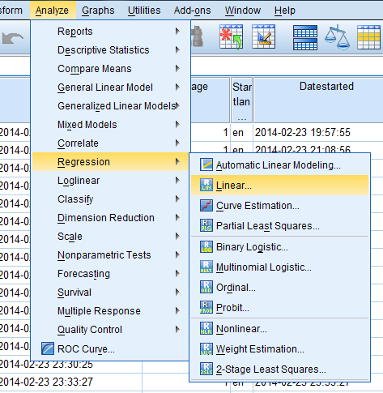

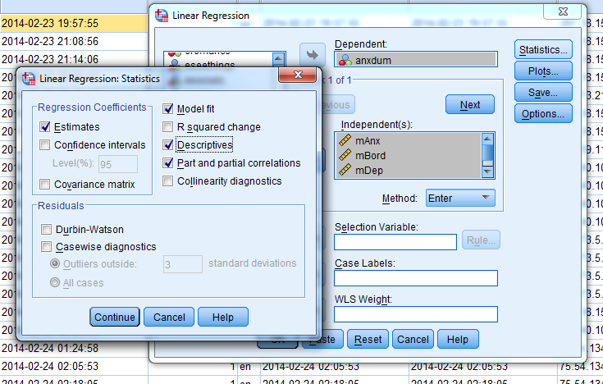

regDiagdum1.sps
REGRESSION
/DESCRIPTIVES MEAN STDDEV CORR SIG N
/MISSING LISTWISE
/STATISTICS COEFF OUTS R ANOVA ZPP
/CRITERIA=PIN(.05) POUT(.10)
/NOORIGIN
/DEPENDENT anxdum
/METHOD=ENTER mAnx mBord mDep moAnx.

REGRESSION
/DESCRIPTIVES MEAN STDDEV CORR SIG N
/MISSING LISTWISE
/STATISTICS COEFF OUTS R ANOVA ZPP
/CRITERIA=PIN(.05) POUT(.10)
/NOORIGIN
/DEPENDENT borddum
/METHOD=ENTER mAnx mBord mDep moAnx.

REGRESSION
/DESCRIPTIVES MEAN STDDEV CORR SIG N
/MISSING LISTWISE
/STATISTICS COEFF OUTS R ANOVA ZPP
/CRITERIA=PIN(.05) POUT(.10)
/NOORIGIN
/DEPENDENT depdum
/METHOD=ENTER mAnx mBord mDep moAnx.

REGRESSION
/DESCRIPTIVES MEAN STDDEV CORR SIG N
/MISSING LISTWISE
/STATISTICS COEFF OUTS R ANOVA ZPP
/CRITERIA=PIN(.05) POUT(.10)
/NOORIGIN
/DEPENDENT schisdum
/METHOD=ENTER mAnx mBord mDep moAnx.

MANOVA

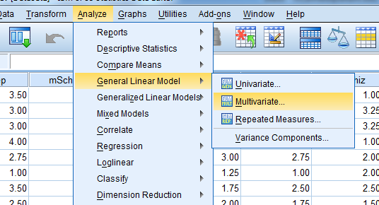

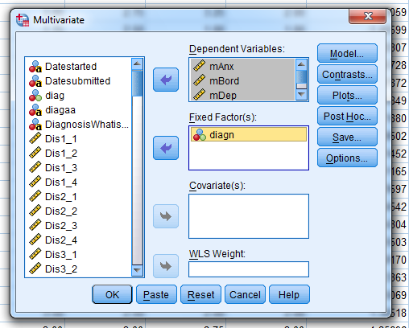

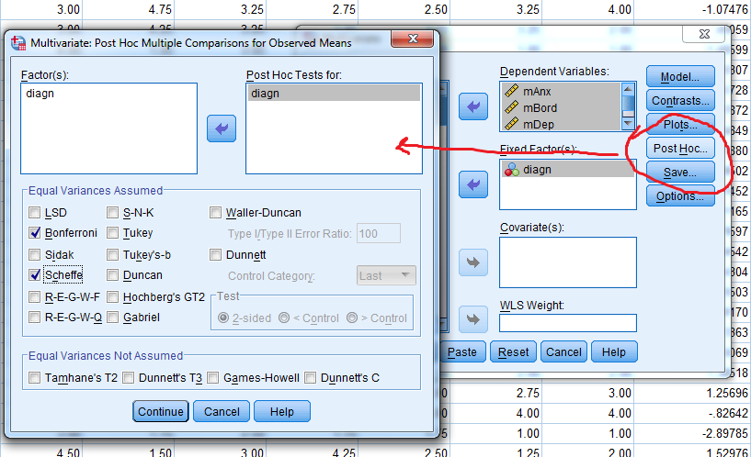

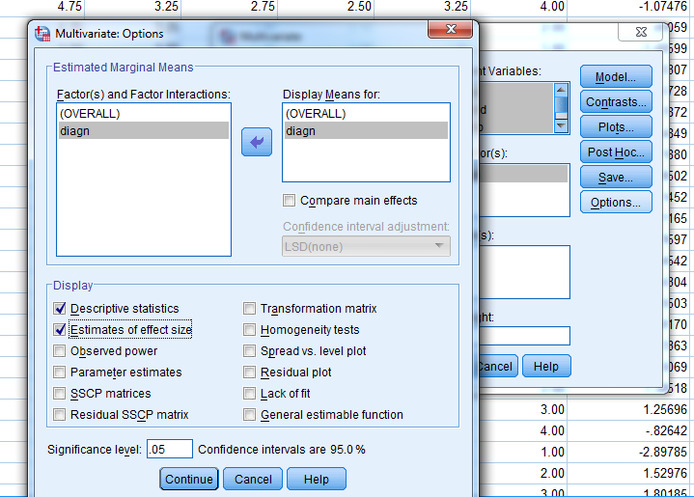
Click on Paste

Manova1.sps
GLM mAnx mBord mDep moAnx BY diagn
/METHOD=SSTYPE(3)
/INTERCEPT=INCLUDE
/POSTHOC=diagn(SCHEFFE BONFERRONI)
/EMMEANS=TABLES(OVERALL)
/EMMEANS=TABLES(diagn)
/PRINT=DESCRIPTIVE ETASQ
/CRITERIA=ALPHA(.05)
/DESIGN= diagn.

Discriminant Analysis

Discriminant Function Analysis

Merle Canfield

The purpose of discriminant is to predict group membership (a categorical or noncontinuous DV) from a set of continuous variables. Diagnostic groups would be the best way to think about what we are doing. How do you diagnose people? This statistic can be used to develop such diagnostic categories or to decide how to assign people categories. That is diagnostic groups.
What is it that contributes to the flu? High fever, drippy nose, runny eyes, achy muscles, and etc. A formula can be developed that will predict whether the person might have the flu or not.
Mathematically MANOVA and discriminant analysis are the same. Although there are some computations that each does and the other does not, the basic difference is that the DVs and IVs are reversed on the continuous and categorical variables. When using MANOVA the IVs are the categorical variables are and the DVs are the continuous. When using discriminant analysis the IVs are the continuous variables and the DVs are the categorical variables. Having pointed out their similarity it should be noted that when they are used in practice the appear to be statistics of a completely different nature.
MANOVA answers the question of whether there are differences in group means of the DVs, while discriminant analysis answers the question of whether the IVs can predict group membership. In this case the methods are still somewhat similar in their purpose. They differ more when discriminant function provides methods of classifying subjects into groups based on the IVs. Consequently, the goals of discriminant analysis are to predict groups and classify subjects with a minimum number of variables. Another task for discriminant is to find the minimum number of variables that maximize the ratio of between-groups sum of squares to within-groups sum of squares.
On the following page is the same questionnaire that has been used throughout the manual with a few added items -- particularly items about change. Seven subtests have been computed from the items.

Discriminant Function

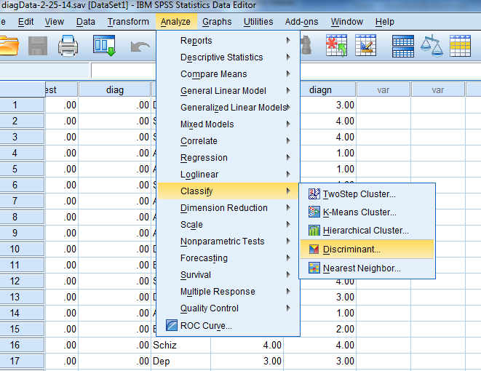

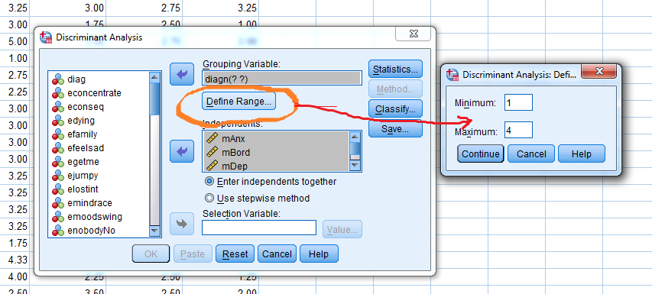

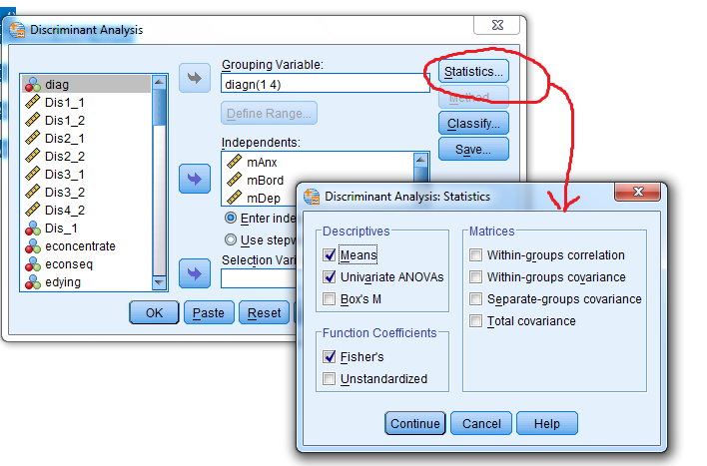

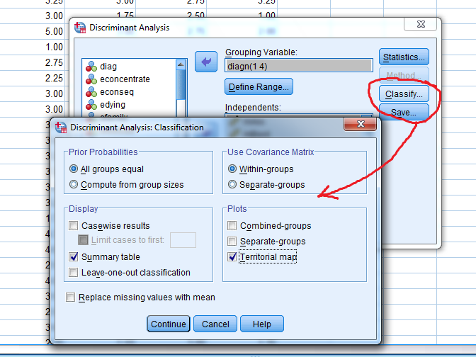

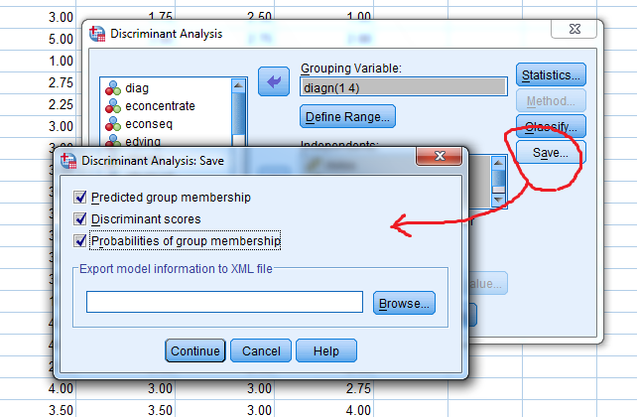
Click Paste
The Clicks produce the following syntax file

Ques14Disc1.sps
DISCRIMINANT
/GROUPS=diagn(1 4)
/VARIABLES=mAnx mBord mDep moAnx
/ANALYSIS ALL
/SAVE=CLASS SCORES PROBS
/PRIORS EQUAL
/STATISTICS=MEAN STDDEV UNIVF COEFF TABLE
/PLOT=MAP
/CLASSIFY=NONMISSING POOLED.

