Chapter 17

Discriminant Function Analysis

Merle Canfield

The purpose of discriminant is to predict group membership (a categorical or noncontinuous DV) from a set of continuous variables. Diagnostic groups would be the best way to think about what we are doing. How do you diagnose people? This statistic can be used to develop such diagnostic categories or to decide how to assign people categories. That is diagnostic groups.
What is it that contributes to the flu? High fever, drippy nose, runny eyes, achy muscles, and etc. A formula can be developed that will predict whether the person might have the flu or not.
Mathematically MANOVA and discriminant analysis are the same. Although there are some computations that each does and the other does not, the basic difference is that the DVs and IVs are reversed on the continuous and categorical variables. When using MANOVA the IVs are the categorical variables are and the DVs are the continuous. When using discriminant analysis the IVs are the continuous variables and the DVs are the categorical variables. Having pointed out their similarity it should be noted that when they are used in practice the appear to be statistics of a completely different nature.
MANOVA answers the question of whether there are differences in group means of the DVs, while discriminant analysis answers the question of whether the IVs can predict group membership. In this case the methods are still somewhat similar in their purpose. They differ more when discriminant function provides methods of classifying subjects into groups based on the IVs. Consequently, the goals of discriminant analysis are to predict groups and classify subjects with a minimum number of variables. Another task for discriminant is to find the minimum number of variables that maximize the ratio of between-groups sum of squares to within-groups sum of squares.
On the following page is the same questionnaire that has been used throughout the manual with a few added items -- particularly items about change. Seven subtests have been computed from the items.

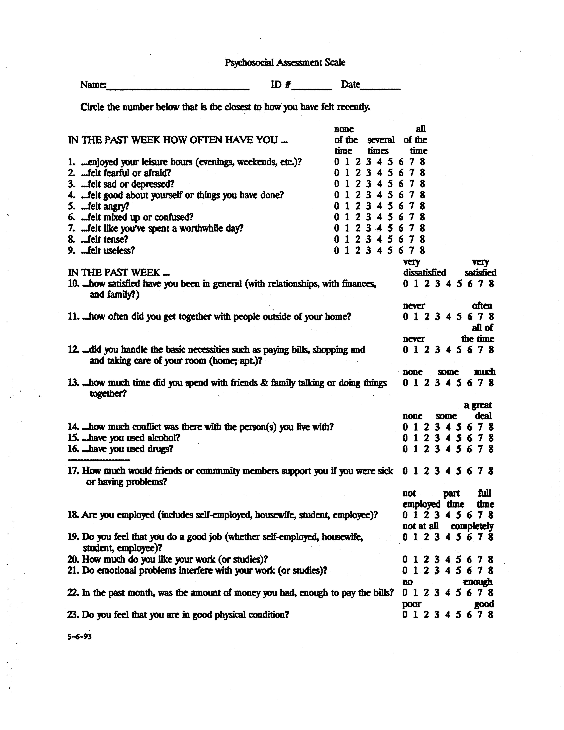

The following spss job stream is used compute the discriminant function on th above questionnaire.

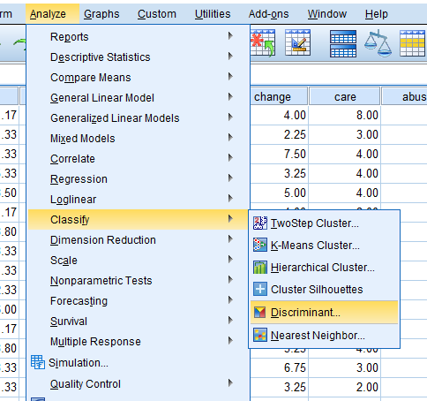

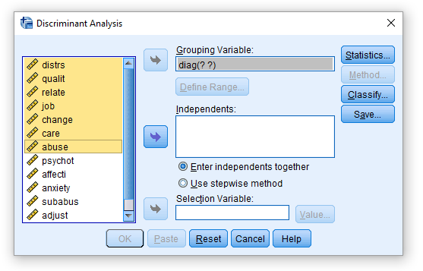
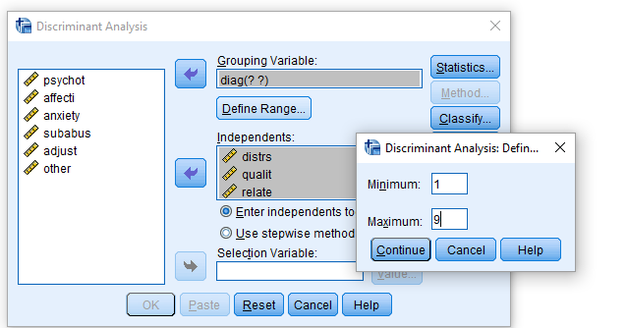

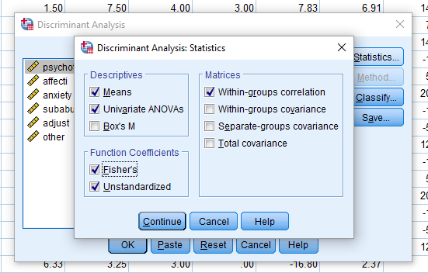

File Name = pasdsc4.sps
DISCRIMINANT
/GROUPS=diag(1 9)
/VARIABLES=distrs qualit relate job change care abuse
/ANALYSIS ALL
/METHOD=MINRESID
/function=6,100,.05
/PIN=.05
/POUT=.10
/PRIORS SIZE
/HISTORY
/STATISTICS=MEAN STDDEV UNIVF COEFF RAW TABLE
/PLOT=MAP
/PLOT=CASES
/CLASSIFY=NONMISSING POOLED.

File Name = pasall4.sav
diag | distrs | qualit | relate | job | change | care | abuse
3.00 | 1.17 | 1.40 | 1.50 | 2.67 | 4.00 | 8.00 | 6.00
5.00 | 1.33 | 3.20 | 4.25 | 3.50 | 2.25 | 3.00 | 2.00
8.00 | 1.33 | 4.20 | 4.75 | 1.50 | 7.50 | 4.00 | 3.00
5.00 | 5.33 | 5.40 | 5.25 | 2.25 | 3.25 | 4.00 | 2.00
4.00 | 3.50 | 2.20 | 4.00 | 3.33 | 5.00 | 4.00 | 7.00
2.00 | 0.17 | 2.80 | 5.33 | 6.25 | 4.00 | 8.00 | 1.00
3.00 | 3.80 | 2.80 | 4.75 | 3.00 | 3.25 | 4.00 | 3.00
3.00 | 3.33 | 4.50 | 7.00 | 4.00 | 6.75 | 3.00 | 8.00
2.00 | 1.33 | 4.80 | 4.50 | 1.50 | 3.25 | 2.00 | 1.00
5.00 | 2.33 | 3.80 | 1.00 | 3.75 | 1.50 | 0.00 | 0.00
8.00 | 6.00 | 5.20 | 4.00 | 3.00 | 5.00 | 7.00 | 0.00
2.00 | 0.17 | 2.80 | 5.33 | 6.25 | 4.00 | 8.00 | 1.00
3.00 | 3.80 | 2.80 | 4.75 | 3.00 | 3.25 | 4.00 | 3.00
3.00 | 3.33 | 4.50 | 7.00 | 4.00 | 6.75 | 3.00 | 8.00
2.00 | 1.33 | 4.80 | 4.50 | 1.50 | 3.25 | 2.00 | 1.00
5.00 | 2.33 | 3.80 | 1.00 | 3.75 | 1.50 | 0.00 | 0.00
8.00 | 6.00 | 5.20 | 4.00 | 3.00 | 5.00 | 7.00 | 0.00
2.00 | 2.00 | 1.40 | 4.00 | 6.33 | 3.25 | 3.00 | 0.00
4.00 | 5.00 | 4.60 | 5.25 | 6.25 | 5.25 | 3.00 | 8.00
5.00 | 3.50 | 4.80 | 5.25 | 2.00 | 5.75 | 6.00 | 0.00
5.00 | 1.50 | 4.75 | 2.00 | 5.00 | 2.00 | 8.00 | 0.00
4.00 | 3.50 | 5.40 | 5.75 | 4.25 | 4.00 | 8.00 | 8.00
2.00 | 2.20 | 3.40 | 5.00 | 4.00 | 1.25 | 3.00 | 0.00
5.00 | 6.00 | 3.00 | 2.50 | 6.00 | 1.50 | 8.00 | 0.00
5.00 | 6.00 | 3.00 | 2.50 | 6.00 | 1.50 | 8.00 | 0.00
1.00 | 7.67 | 8.00 | 6.50 | 4.00 | 8.00 | 8.00 | 3.00
8.00 | 3.83 | 4.40 | 1.50 | 3.25 | 4.25 | 3.00 | 3.00
3.00 | 6.50 | 4.40 | 6.00 | 4.00 | 7.00 | 9.00 | 0.00
4.00 | 3.50 | 4.00 | 5.75 | 5.25 | 5.00 | 6.00 | 6.00
3.00 | 2.67 | 5.00 | 4.00 | 5.25 | 6.00 | 4.00 | 0.00
3.00 | 2.67 | 5.00 | 4.00 | 5.25 | 6.00 | 4.00 | 0.00
2.00 | 2.00 | 1.00 | 3.00 | 2.25 | 2.50 | 2.00 | 7.00

The variables DISTRS, QUALIT, RELATE, JOB, CHANGE, CARE, and ABUSE are subtest of the questionnaire. Their reliability was tested in the reliability chapter. The subtests are comprised of the items in the following manner.

DISTRS
FEARFUL, DEPRESSED; ANGRY CONFUSED; TENSE
QUALIT

LEISURE; FEEL GOOD ABOUT SELF; WORTHWILE DAY; BORED OR USELESS;
RELATE
SATISFIED; GET TOGETHER; SPEND TIME WITH FRIENDS; CONFLICT
JOB
EMPLOYED; GOOD JOB; LIKE WORK; PROBLEMS INTERFERE; AMOUNT OF MONEY
CHANGE
SENSE OF HUMOR; SEE THINGS DIFFERENT; CHANGE IN LIFE; MORE SENSE
SELCAR
HANDLE BASIC NECESSITIES
ALCDRUG
USE ALCOHOL OR DRUGS
Group Statistics
diag |  | Mean | Std. Deviation | Valid N (listwise)
 |  |  |  | Unweighted | Weighted
psychotic | distrs | 7.6700 | .ª | 1 | 1.000
 | qualit | 8.0000 | .ª | 1 | 1.000
 | relate | 6.5000 | .ª | 1 | 1.000
 | job | 4.0000 | .ª | 1 | 1.000
 | change | 8.0000 | .ª | 1 | 1.000
 | care | 8.0000 | .ª | 1 | 1.000
 | abuse | 3.0000 | .ª | 1 | 1.000
affective | distrs | 1.3143 | .85090 | 7 | 7.000
 | qualit | 3.0000 | 1.48773 | 7 | 7.000
 | relate | 4.5229 | .82907 | 7 | 7.000
 | job | 4.0114 | 2.27726 | 7 | 7.000
 | change | 3.0714 | .95431 | 7 | 7.000
 | care | 4.0000 | 2.76887 | 7 | 7.000
 | abuse | 1.5714 | 2.43975 | 7 | 7.000
anxiety | distrs | 3.4088 | 1.51081 | 8 | 8.000
 | qualit | 3.8000 | 1.30822 | 8 | 8.000
 | relate | 4.8750 | 1.82248 | 8 | 8.000
 | job | 3.8963 | .98617 | 8 | 8.000
 | change | 5.3750 | 1.60913 | 8 | 8.000
 | care | 4.8750 | 2.29518 | 8 | 8.000
 | abuse | 3.5000 | 3.46410 | 8 | 8.000
sub-abuse | distrs | 3.8750 | .75000 | 4 | 4.000
 | qualit | 4.0500 | 1.36015 | 4 | 4.000
 | relate | 5.1875 | .82601 | 4 | 4.000
 | job | 4.7700 | 1.26026 | 4 | 4.000
 | change | 4.8125 | .55434 | 4 | 4.000
 | care | 5.2500 | 2.21736 | 4 | 4.000
 | abuse | 7.2500 | .95743 | 4 | 4.000
adjustment | distrs | 3.5400 | 1.97422 | 8 | 8.000
 | qualit | 3.9688 | .91610 | 8 | 8.000
 | relate | 2.9688 | 1.73945 | 8 | 8.000
 | job | 4.0313 | 1.53202 | 8 | 8.000
 | change | 2.4063 | 1.48166 | 8 | 8.000
 | care | 4.6250 | 3.42000 | 8 | 8.000
 | abuse | .5000 | .92582 | 8 | 8.000
other | distrs | 4.2900 | 2.22272 | 4 | 4.000
 | qualit | 4.7500 | .52599 | 4 | 4.000
 | relate | 3.5625 | 1.41973 | 4 | 4.000
 | job | 2.6875 | .80039 | 4 | 4.000
 | change | 5.4375 | 1.41973 | 4 | 4.000
 | care | 5.2500 | 2.06155 | 4 | 4.000
 | abuse | 1.5000 | 1.73205 | 4 | 4.000
Total | distrs | 3.2850 | 1.93943 | 32 | 32.000
 | qualit | 3.9484 | 1.42577 | 32 | 32.000
 | relate | 4.2472 | 1.64508 | 32 | 32.000
 | job | 3.9166 | 1.50455 | 32 | 32.000
 | change | 4.1484 | 1.91436 | 32 | 32.000
 | care | 4.8125 | 2.59575 | 32 | 32.000
 | abuse | 2.5313 | 2.99445 | 32 | 32.000
a. Insufficient data
Tests of Equality of Group Means
 | Wilks' Lambda | F | df1 | df2 | Sig.
distrs | .550 | 4.257 | 5 | 26 | .006
qualit | .595 | 3.535 | 5 | 26 | .014
relate | .675 | 2.501 | 5 | 26 | .056
job | .870 | .778 | 5 | 26 | .574
change | .404 | 7.663 | 5 | 26 | .000
care | .920 | .450 | 5 | 26 | .810
abuse | .495 | 5.315 | 5 | 26 | .002
Pooled Within-Groups Matrices
 |  | distrs | qualit | relate | job | change | care | abuse
Correlation | distrs | 1.000 | .110 | .227 | .136 | -.089 | .227 | -.211
 | qualit | .110 | 1.000 | .477 | -.109 | .382 | -.055 | -.270
 | relate | .227 | .477 | 1.000 | -.065 | .613 | .162 | .096
 | job | .136 | -.109 | -.065 | 1.000 | -.034 | .384 | -.327
 | change | -.089 | .382 | .613 | -.034 | 1.000 | .105 | .033
 | care | .227 | -.055 | .162 | .384 | .105 | 1.000 | -.257
 | abuse | -.211 | -.270 | .096 | -.327 | .033 | -.257 | 1.000
Analysis 1
Stepwise Statistics
Variables Entered/Removed^{a,b,c,d}
Step | Entered | Residual Variance
1 | change | 8.948
2 | abuse | 6.885
3 | distrs | 5.330
4 | relate | 4.376
At each step, the variable that minimizes the sum of the unexplained variation for all pairs of groups is entered.
a. Maximum number of steps is 14.
b. Maximum significance of F to enter is .05.
c. Minimum significance of F to remove is .10.
d. F level, tolerance, or VIN insufficient for further computation.
Variables in the Analysis
Step |  | Tolerance | Sig. of F to Remove | Residual Variance
1 | change | 1.000 | .000
2 | change | .999 | .001 | #####
 | abuse | .999 | .008 | 8.948
3 | change | .992 | .003 | 7.219
 | abuse | .955 | .007 | 7.106
 | distrs | .949 | .014 | 6.885
4 | change | .562 | .000 | 6.530
 | abuse | .922 | .010 | 5.598
 | distrs | .806 | .003 | 6.035
 | relate | .525 | .032 | 5.330
Variables Not in the Analysis
Step |  | Tolerance | Min. Tolerance | Sig. of F to Enter | Residual Variance
0 | distrs | 1.000 | 1.000 | .006 | 10.091
 | qualit | 1.000 | 1.000 | .014 | 10.247
 | relate | 1.000 | 1.000 | .056 | 11.729
 | job | 1.000 | 1.000 | .574 | 13.824
 | change | 1.000 | 1.000 | .000 | 8.948
 | care | 1.000 | 1.000 | .810 | 13.539
 | abuse | 1.000 | 1.000 | .002 | 11.115
1 | distrs | .992 | .992 | .016 | 7.106
 | qualit | .854 | .854 | .058 | 7.640
 | relate | .624 | .624 | .079 | 7.546
 | job | .999 | .999 | .623 | 8.273
 | care | .989 | .989 | .955 | 8.761
 | abuse | .999 | .999 | .008 | 6.885
2 | distrs | .949 | .949 | .014 | 5.330
 | qualit | .773 | .773 | .072 | 5.812
 | relate | .618 | .618 | .126 | 6.035
 | job | .892 | .892 | .292 | 6.207
 | care | .921 | .921 | .859 | 6.643
3 | qualit | .766 | .766 | .295 | 4.896
 | relate | .525 | .525 | .032 | 4.376
 | job | .888 | .865 | .317 | 4.800
 | care | .886 | .886 | .980 | 5.267
4 | qualit | .659 | .452 | .121 | 3.777
 | job | .885 | .523 | .368 | 3.975
 | care | .879 | .521 | .986 | 4.327
Wilks' Lambda
Step | Number of Variables | Lambda | df1 | df2 | df3 | Exact F |  |  |  |  | Approximate F
 |  |  |  |  |  | Statistic | df1 | df2 |  | Sig. | Statistic | df1 | df2 | Sig.
1 | 1 | .404 | 1 | 5 | 26 | 7.663 | 5 | ##### |  | .000
2 | 2 | .222 | 2 | 5 | 26 | 5.604 | 10 | ##### |  | .000
3 | 3 | .127 | 3 | 5 | 26 |  |  |  |  |  | 4.952 | 15 | 66.655 | .000
4 | 4 | .077 | 4 | 5 | 26 |  |  |  |  |  | 4.514 | 20 | 77.232 | .000
Summary of Canonical Discriminant Functions
Eigenvalues^{a,b}
Function | Eigenvalue | % of Variance | Cumulative % | Canonical Correlation
1 | 3.444^{c} | 70.8 | 70.8 | .880
2 | .968^{c} | 19.9 | 90.6 | .701
3 | .356 | 7.3 | 98.0 | .513
4 | .099 | 2.0 | 100.0 | .300
a. Maximum number of functions is 5.
b. Minimum cumulative percent of variance is 100.
c. First 2 canonical discriminant functions were used in the analysis.
Wilks' Lambda
Test of Function(s) | Wilks' Lambda | Chi-square | df | Sig.
1 through 4 | .077 | 66.764 | 20 | .000
2 through 4 | .341 | 27.983 | 12 | .006
3 through 4 | .671 | 10.379 | 6 | .110
4 | .910 | 2.456 | 2 | .293
Maximum significance of Wilks' Lambda is .05.
Standardized Canonical Discriminant Function Coefficients
 | Function
 | 1 | 2
distrs | .780 | -.378
relate | -.724 | .722
change | 1.092 | -.289
abuse | .499 | .680
Structure Matrix
 | Function
 | 1 | 2
change | .595* | .210
distrs | .414* | -.331
qualit^{b} | .023* | .008
abuse | .302 | .819*
relate | .170 | .524*
job^{b} | -.047 | -.311*
care^{b} | .046 | -.173*
Pooled within-groups correlations between discriminating variables and standardized canonical discriminant functions
Variables ordered by absolute size of correlation within function.
*. Largest absolute correlation between each variable and any discriminant function
b. This variable not used in the analysis.
Canonical Discriminant Function Coefficients
 | Function
 | 1 | 2
distrs | .497 | -.241
relate | -.491 | .489
change | .822 | -.217
abuse | .217 | .296
(Constant) | -3.506 | -1.134
Unstandardized coefficients
Functions at Group Centroids
diag | Function
 | 1 | 2
psychotic | 4.340 | -.652
affective | -2.208 | .559
anxiety | .972 | .297
sub-abuse | 1.402 | 1.569
adjustment | -1.118 | -.909
other | 1.671 | -1.162
Unstandardized canonical discriminant functions evaluated at group means
Classification Statistics
Classification Processing Summary
Processed |  | 32
Excluded | Missing or out-of-range group codes | 0
 | At least one missing discriminating variable | 0
Used in Output |  | 32
Prior Probabilities for Groups
diag | Prior | Cases Used in Analysis
 |  | Unweighted | Weighted
psychotic | .167 | 1 | 1.000
affective | .167 | 7 | 7.000
anxiety | .167 | 8 | 8.000
sub-abuse | .167 | 4 | 4.000
adjustment | .167 | 8 | 8.000
other | .167 | 4 | 4.000
Total | 1.000 | 32 | 32.000
Classification Function Coefficients
 | diag
 | psychotic | affective | anxiety | sub-abuse | adjustment | other
distrs | 4.224 | .315 | 1.954 | 2.297 | 1.596 | 2.581
relate | -1.472 | 1.594 | -.213 | -.009 | .158 | -1.468
change | 5.908 | .673 | 3.342 | 2.876 | 1.406 | 4.311
abuse | 1.152 | .231 | .892 | 1.647 | .287 | .662
(Constant) | -38.567 | -6.818 | -15.144 | ##### | -6.614 | #####
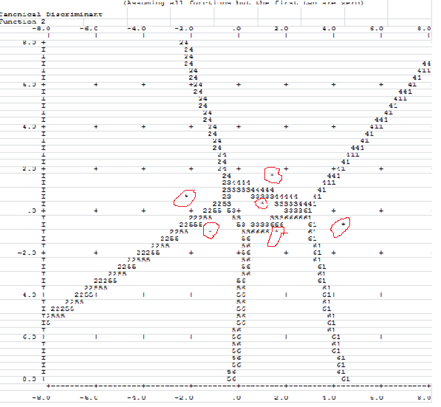
Canonical Discriminant Function 1
Symbols used in territorial map
Symbol Group Label
------ ----- --------------------
1 1 psychotic
2 2 affective
3 3 anxiety
4 4 sub-abuse
5 5 adjustment
6 8 other
* Indicates a group centroid

Casewise Statistics
Case Number |  | Actual Group | Highest Group |  |  |  |  | Second Highest Group |  |  | Discriminant Scores
 |  |  | Predicted Group | P(D>d | G=g) |  | P(G=g | D=d) | Squared Mahalanobis Distance to Centroid | Group | P(G=g | D=d) | Squared Mahalanobis Distance to Centroid | Function 1 | Function 2
 |  |  |  | p | df
Original | 1 | 3 | 3 | .996 | 2 | .578 | .007 | 4 | .210 | 2.036 | .928 | .223
 | 2 | 5 | 2** | .895 | 2 | .915 | .222 | 5 | .083 | 5.016 | -2.648 | .727
 | 3 | 8 | 3** | .790 | 2 | .493 | .472 | 8 | .272 | 1.661 | 1.637 | .126
 | 4 | 5 | 5 | .469 | 2 | .401 | 1.516 | 3 | .355 | 1.760 | -.329 | .037
 | 5 | 4 | 4 | .736 | 2 | .535 | .613 | 3 | .379 | 1.303 | 1.898 | .964
 | 6 | 2 | 2 | .907 | 2 | .920 | .196 | 5 | .078 | 5.127 | -2.534 | .859
 | 7 | 3 | 5** | .349 | 2 | .350 | 2.103 | 2 | .286 | 2.510 | -.627 | .456
 | 8 | 3 | 4** | .600 | 2 | .897 | 1.023 | 3 | .100 | 5.419 | 1.996 | 2.387
 | 9 | 2 | 2 | .975 | 2 | .780 | .051 | 5 | .213 | 2.649 | -2.166 | .337
 | 10 | 5 | 5 | .731 | 2 | .874 | .626 | 2 | .112 | 4.732 | -1.607 | -1.531
 | 11 | 8 | 8 | .861 | 2 | .856 | .300 | 3 | .108 | 4.441 | 1.621 | -1.708
 | 12 | 2 | 2 | .907 | 2 | .920 | .196 | 5 | .078 | 5.127 | -2.534 | .859
 | 13 | 3 | 5** | .349 | 2 | .350 | 2.103 | 2 | .286 | 2.510 | -.627 | .456
 | 14 | 3 | 4** | .600 | 2 | .897 | 1.023 | 3 | .100 | 5.419 | 1.996 | 2.387
 | 15 | 2 | 2 | .975 | 2 | .780 | .051 | 5 | .213 | 2.649 | -2.166 | .337
 | 16 | 5 | 5 | .731 | 2 | .874 | .626 | 2 | .112 | 4.732 | -1.607 | -1.531
 | 17 | 8 | 8 | .861 | 2 | .856 | .300 | 3 | .108 | 4.441 | 1.621 | -1.708
 | 18 | 2 | 5** | .681 | 2 | .523 | .767 | 2 | .462 | 1.016 | -1.805 | -.365
 | 19 | 4 | 4 | .572 | 2 | .729 | 1.117 | 3 | .217 | 3.536 | 2.453 | 1.456
 | 20 | 5 | 3** | .532 | 2 | .410 | 1.261 | 8 | .295 | 1.918 | .381 | -.658
 | 21 | 5 | 5 | .618 | 2 | .657 | .964 | 2 | .338 | 2.293 | -2.099 | -.951
 | 22 | 4 | 4 | .468 | 2 | .799 | 1.519 | 3 | .186 | 4.431 | .435 | 2.333
 | 23 | 2 | 2 | .264 | 2 | .967 | 2.665 | 5 | .033 | 9.421 | -3.840 | .511
 | 24 | 5 | 5 | .620 | 2 | .809 | .955 | 8 | .104 | 5.063 | -.519 | -1.681
 | 25 | 5 | 5 | .620 | 2 | .809 | .955 | 8 | .104 | 5.063 | -.519 | -1.681
 | 26 | 1 | 1 | 1.000 | 2 | .973 | 0.000 | 8 | .024 | 7.386 | 4.340 | -.652
 | 27 | 8 | 8 | .972 | 2 | .804 | .056 | 3 | .149 | 3.434 | 1.804 | -1.358
 | 28 | 3 | 8** | .686 | 2 | .729 | .755 | 1 | .169 | 3.674 | 2.531 | -1.284
 | 29 | 4 | 4 | .844 | 2 | .628 | .338 | 3 | .347 | 1.527 | .822 | 1.524
 | 30 | 3 | 8** | .676 | 2 | .554 | .782 | 3 | .294 | 2.053 | .787 | -1.124
 | 31 | 3 | 8** | .676 | 2 | .554 | .782 | 3 | .294 | 2.053 | .787 | -1.124
 | 32 | 2 | 3** | .214 | 2 | .353 | 3.080 | 4 | .313 | 3.322 | -.411 | 1.379
**. Misclassified case

Classification Resultsª
diag |  |  | Predicted Group Membership |  |  |  |  |  | Total
 |  |  | psychotic | affective | anxiety | sub-abuse | adjustment | other
Original | Count | psychotic | 1 | 0 | 0 | 0 | 0 | 0 | 1
 |  | affective | 0 | 5 | 1 | 0 | 1 | 0 | 7
 |  | anxiety | 0 | 0 | 1 | 2 | 2 | 3 | 8
 |  | sub-abuse | 0 | 0 | 0 | 4 | 0 | 0 | 4
 |  | adjustment | 0 | 1 | 1 | 0 | 6 | 0 | 8
 |  | other | 0 | 0 | 1 | 0 | 0 | 3 | 4
 | % | psychotic | 100.0 | 0.0 | 0.0 | 0.0 | 0.0 | 0.0 | 100.0
 |  | affective | 0.0 | 71.4 | 14.3 | 0.0 | 14.3 | 0.0 | 100.0
 |  | anxiety | 0.0 | 0.0 | 12.5 | 25.0 | 25.0 | 37.5 | 100.0
 |  | sub-abuse | 0.0 | 0.0 | 0.0 | 100.0 | 0.0 | 0.0 | 100.0
 |  | adjustment | 0.0 | 12.5 | 12.5 | 0.0 | 75.0 | 0.0 | 100.0
 |  | other | 0.0 | 0.0 | 25.0 | 0.0 | 0.0 | 75.0 | 100.0
a. 62.5% of original grouped cases correctly classified.

File Name = cmpdsc1.sps
compute psychot = ( distrs*4.223727)+((-1.471706)*relate)+(change*5.908059).
compute psychot = psychot+(abuse*1.151814)+(-38.56666).
compute affecti = (distrs*.3147697)+(relate*1.593594)+(change*.6730551).
compute affecti = affecti +(abuse*.2313193)+(-6.817778).
compute anxiety = ( distrs*1.954008)+((-.1231648)*relate)+(change*3.341649).
compute anxiety = anxiety+(abuse*.8917886)+(-15.14384).
compute subabus = (distrs*2.29737)+(relate*(-.008612015))+(change*2.876287).
compute subabus = subabus +(abuse*1.646836)+(-19.11142).
compute adjust = ( distrs*1.596124)+(.1578773*relate)+(change*1.405559).
compute adjust = adjust+(abuse*.2873630)+(-6.614153).
compute other = (distrs*2.581243)+(relate*(-1.467931))+(change*4.310739).
compute other = other +(abuse*.6623786)+(-16.93038).
list psychot affecti anxiety subabus adjust other
/format=wrap numbered.

PSYCHOT AFFECTI ANXIETY SUBABUS ADJUST OTHER

1 -5.29 .02 5.67 4.95 2.84 5.11
2 -23.61 2.35 -3.77 -6.33 -.08 -8.71
3 7.83 6.91 14.61 10.42 7.66 13.85
4 -2.28 5.88 7.27 5.73 7.86 4.46
5 7.93 5.64 14.15 14.80 8.64 12.42
6 -20.91 4.65 -1.21 -5.61 .41 -6.41
7 -6.85 4.83 5.23 3.87 5.63 1.90
8 14.29 11.78 20.19 21.07 11.59 15.79
9 -19.22 3.19 -1.35 -5.10 1.07 -5.43
10 -21.33 -3.48 -5.70 -9.45 -.63 -5.92
11 10.43 4.81 12.80 9.02 10.62 14.24
12 -20.91 4.65 -1.21 -5.61 .41 -6.41
13 -6.85 4.83 5.23 3.87 5.63 1.90
14 14.29 11.78 20.19 21.07 11.59 15.79
15 -19.22 3.19 -1.35 -5.10 1.07 -5.43
16 -21.33 -3.48 -5.70 -9.45 -.63 -5.92
17 10.43 4.81 12.80 9.02 10.62 14.24
18 -16.80 2.37 -.87 -5.20 1.78 -3.63
19 15.06 8.51 18.66 20.61 11.87 16.20
20 2.46 6.52 10.26 5.42 7.88 9.18
21 -23.36 -1.81 -5.78 -9.93 -1.09 -7.37
22 .60 7.99 11.49 13.56 7.80 6.21
23 -29.25 2.68 -7.28 -10.50 -.56 -13.20
24 -8.04 .06 1.28 -1.03 5.47 1.35
25 -8.04 .06 1.28 -1.03 5.47 1.35
26 34.98 12.03 28.45 26.40 18.76 29.80
27 3.97 .33 9.03 6.84 6.57 11.06
28 21.41 9.50 20.21 15.90 14.55 21.22
29 4.21 8.20 13.05 13.14 8.63 9.19
30 2.27 4.44 9.63 4.25 6.71 9.95
31 2.27 4.44 9.63 4.25 6.71 9.95
32 -11.70 1.89 2.99 4.18 2.58 -.76

Number of cases read: 32 Number of cases listed: 32

File Name = cmpdsc2.sps

compute fun1 = ( distrs*0.4970089)+((-.4907447)*relate)+(change*0.8215985).
compute fun1 = fun1+(abuse*0.2171575)+(-3.506419).
compute fun2 = (distrs*(-0.2405888))+(relate*0.4891394)+(change*(-0.2173887)).
compute fun2 = fun2 +(abuse*0.2956920)+(-1.133779).
list fun1 fun2
/format=wrap numbered.

FUN1 FUN2

1 .93 .22
2 -2.65 .73
3 1.64 .13
4 -.33 .04
5 1.90 .96
6 -2.53 .86
7 -.63 .46
8 2.00 2.39
9 -2.17 .34
10 -1.61 -1.53
11 1.62 -1.71
12 -2.53 .86
13 -.63 .46
14 2.00 2.39
15 -2.17 .34
16 -1.61 -1.53
17 1.62 -1.71
18 -1.81 -.36
19 2.45 1.46
20 .38 -.66
21 -2.10 -.95
22 .43 2.33
23 -3.84 .51
24 -.52 -1.68
25 -.52 -1.68
26 4.34 -.65

27 1.80 -1.36
28 2.53 -1.28
29 .82 1.52
30 .79 -1.12
31 .79 -1.12
32 -.41 1.38

Number of cases read: 32 Number of cases listed: 32

