Y' = a + bX prediction formula
Y = a + bX+e general linear model

correlation
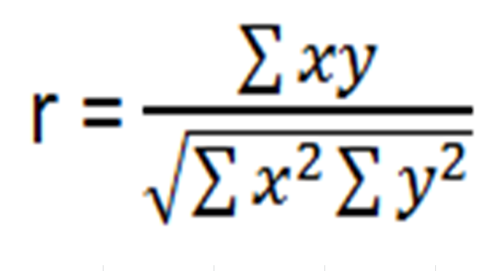

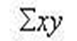 sums of square cross products

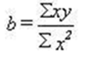 beta

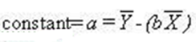

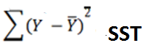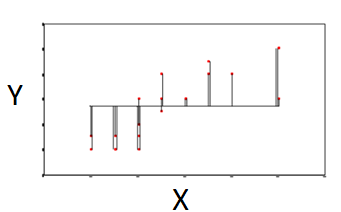
Sums of squares total

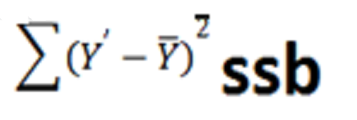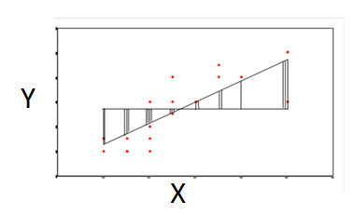
Sums of squares between

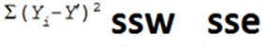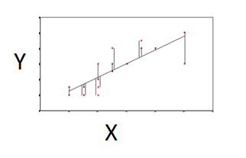
Sums of squares within or sums of squares error
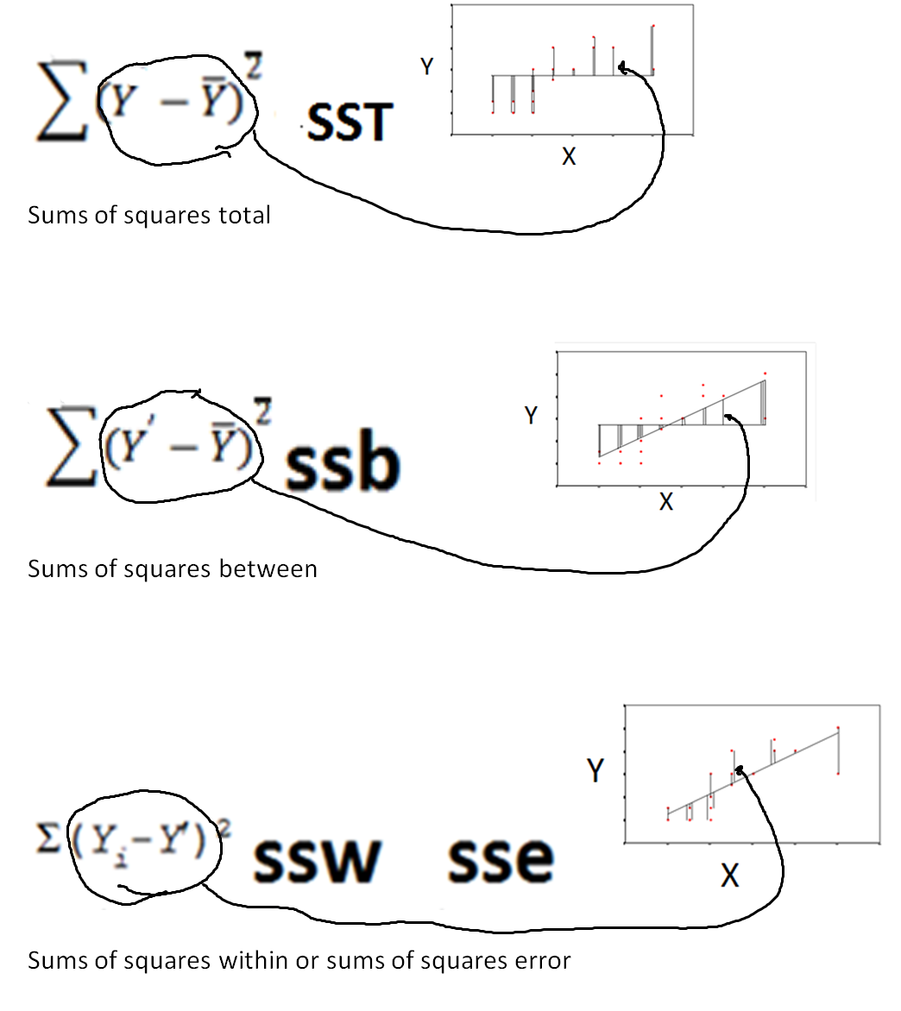
&&&&&&&&&&&&&&&&&&&&&&&&&&&&&&&&&&&&&&&&&&&&&&&&&&&&&&&&&&
Non-standardized linear combination
Y’=a + b₁X₁ + b₂X₂ + b₃X_{3…} b_{n}X_{n}
Standardized linear combination
Y’=b₁X₁ + b₂X₂ + b₃X_{3…} b_{n}X_{n}

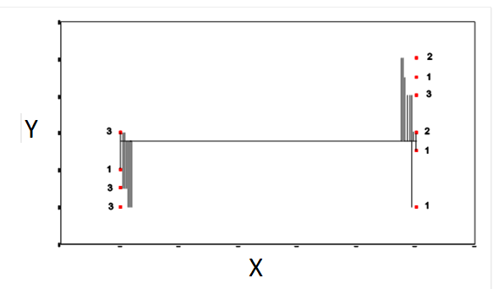
Sums of squares total

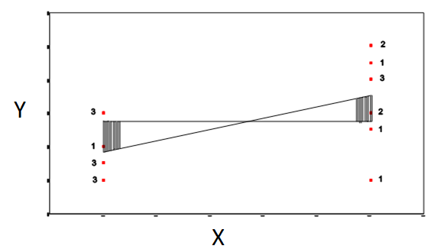
Sums of squares between

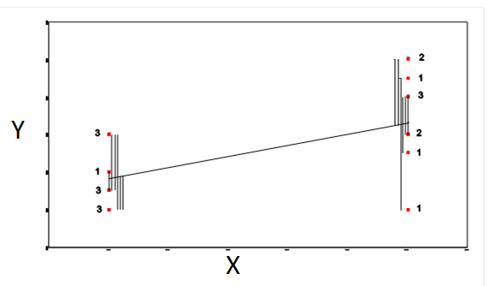
Sums of squares within or sums of squares error

Pearson correlation coefficient | correlation | r | $\sqrt{\frac{SSB}{SST}}$  $\frac{Σxy}{\sqrt{Σx^{2}Σy^{2}}}$ | R² = t² / (t² + DF),
Analysis of Variance | ANOVA | F | SSB/SSW  (only applies when groups=2) | f=t²
t-test | t-test | t | $$\sqrt{\frac{SSB}{SSW}}$$ | t² = DF*R² / (1 - R²)  $$t=\sqrt{f}$$

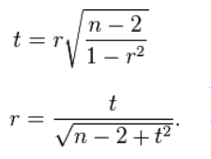`

$n^{2}$=$\frac{t^{2}}{t^{2}+df}$ eta squared = SSB/SST

