Bare minimum to create a Qualtrics survey.
Canfield 10/25/18
Find Qualtrics by a search in My Alliant.
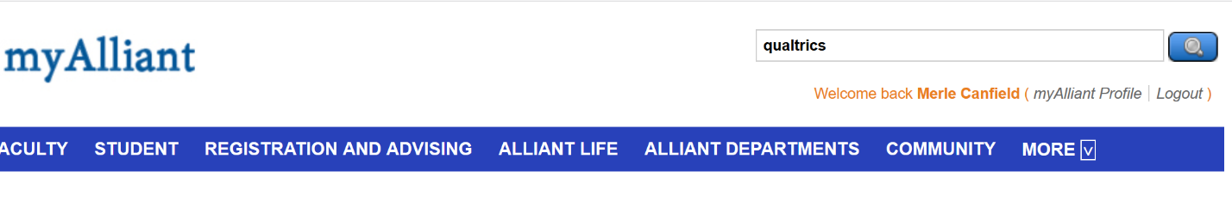

Click on Resources and Tools below:

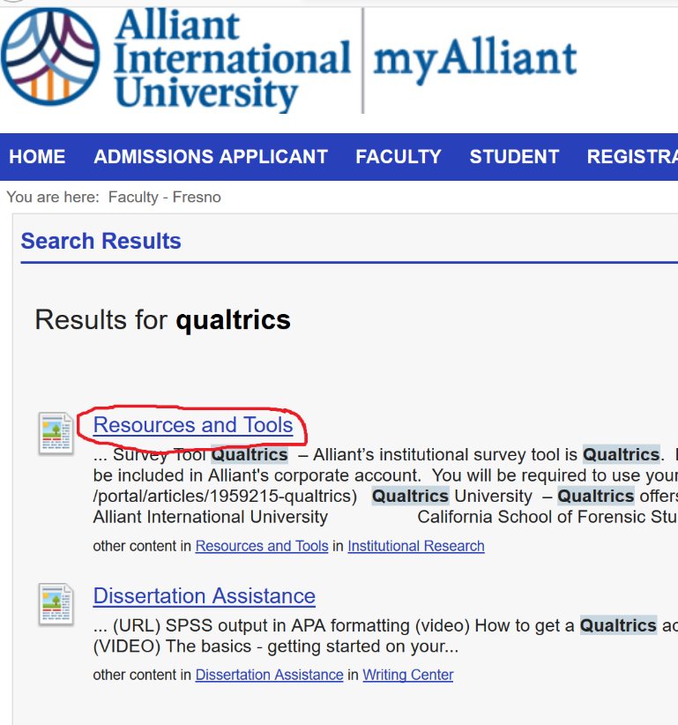

Click on Qualtrics below:

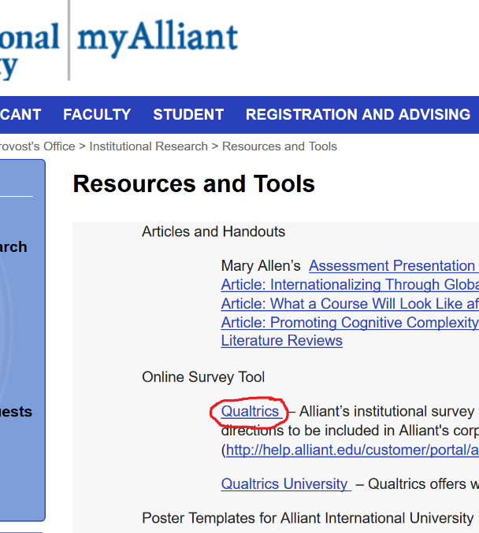
Click on Create a Project below:

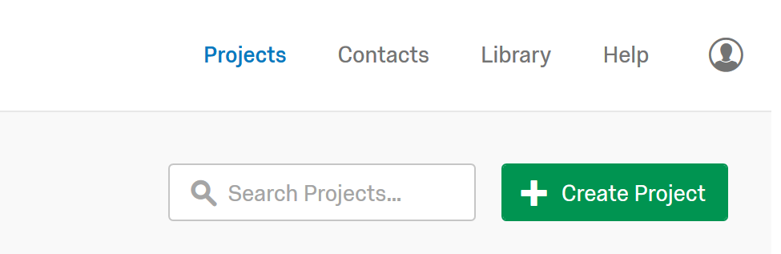

Click on Blank Survey Project below:

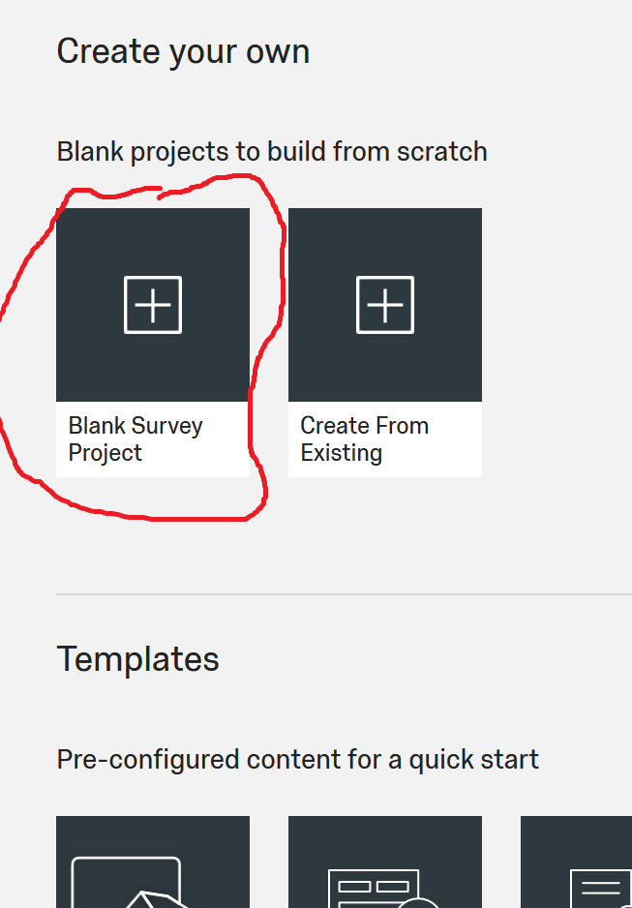

Type in the name of your new project. Then click Create Project below:
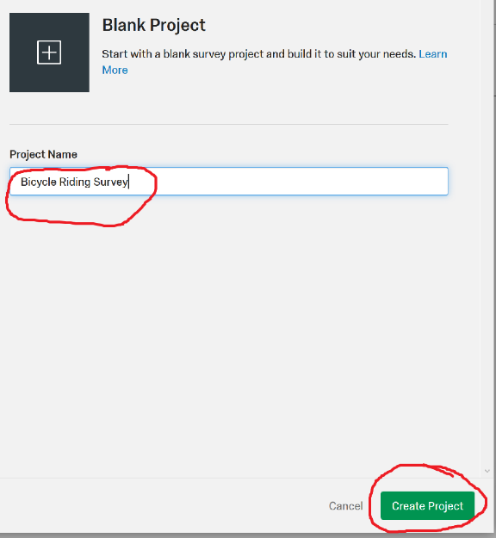
The project “defaults” to multiple choice and that is what you want for a Liket type item. I usually want 5 responses so click the plus two to add two more responses. Then click Horizontal to save space on your form.
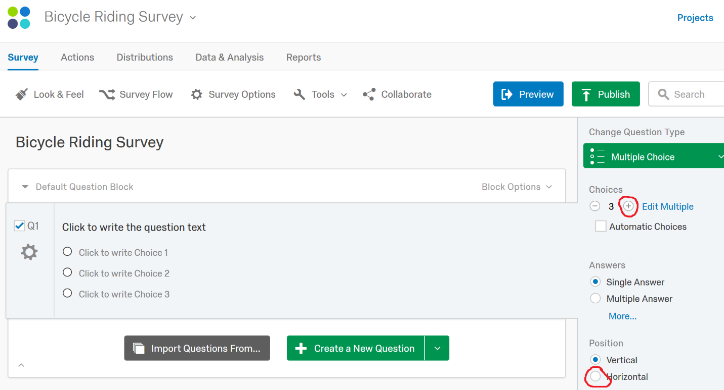
Then in the stem for the first item in the space labeled “Click to write the question text”
Then in the “Click to write Choice 1 type “strongly disagree” and the program will fill in the rest of the choices. See below:
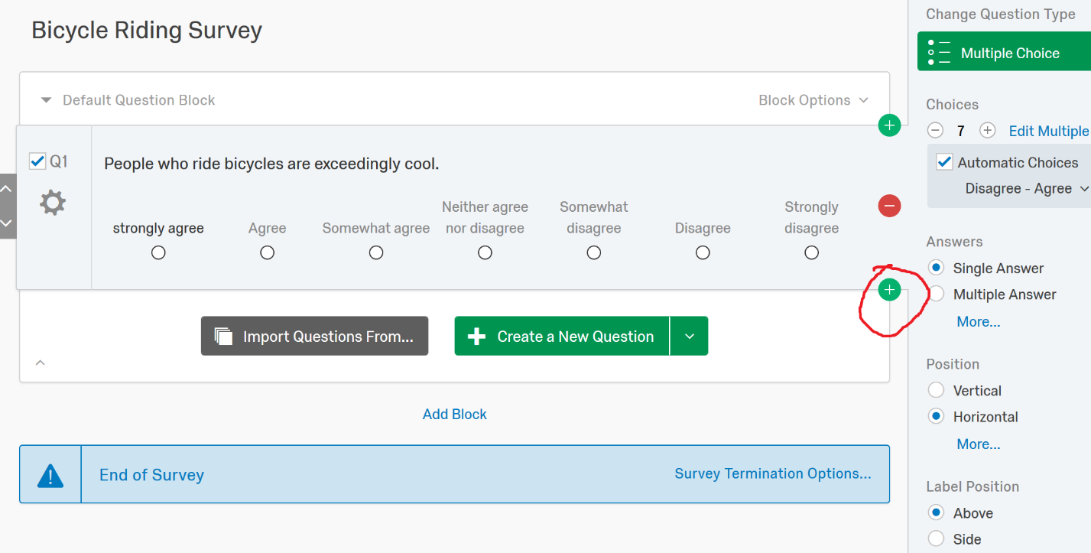
Then “mouse over” the item and three buttons will appear on the right hand side of the item. Click the green bottom button with a plus sign on it to add a new item.
Once you have created all of the items desired click Publish:
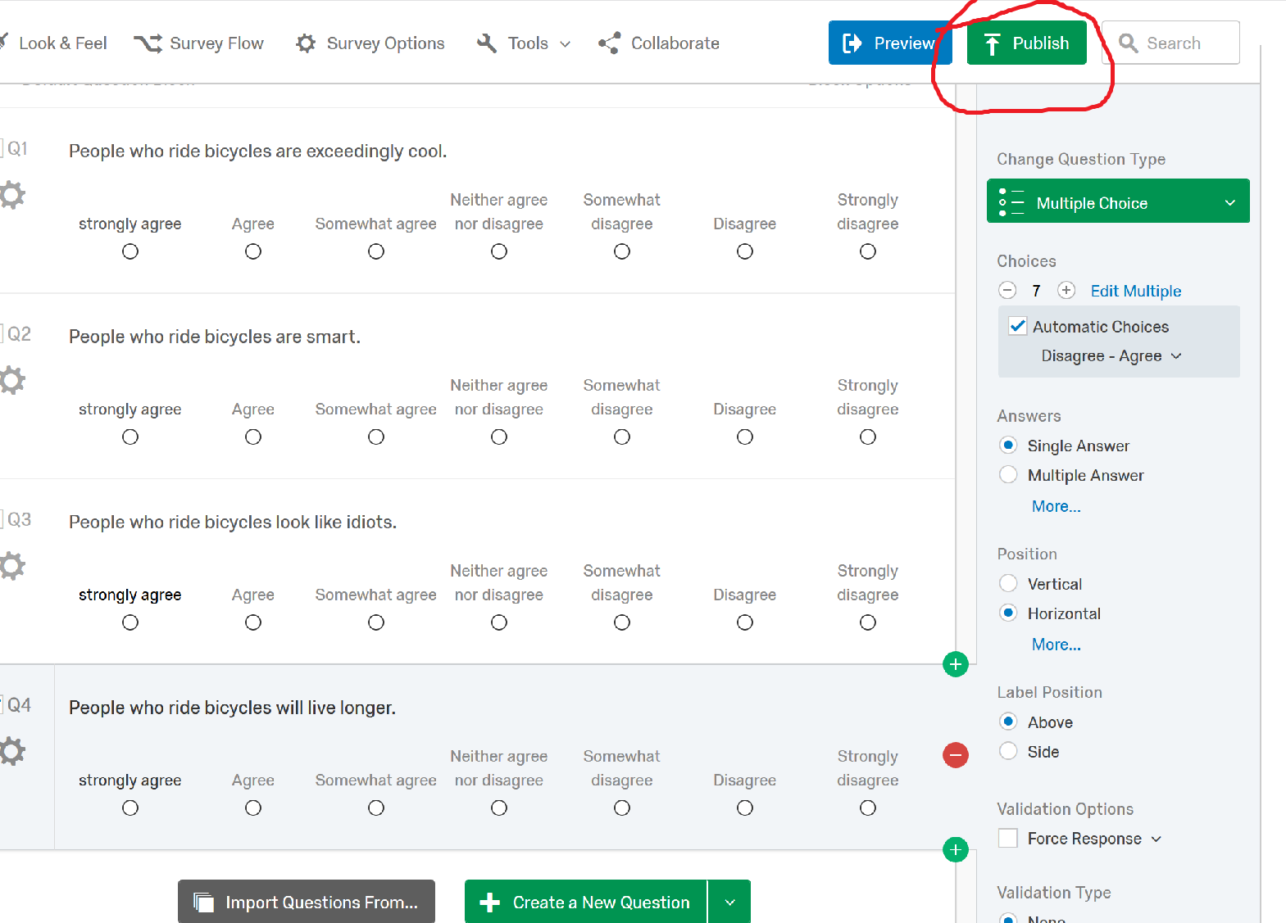

The following window will appear with a link that you need to copy and send to those that you would like to complete the survey.
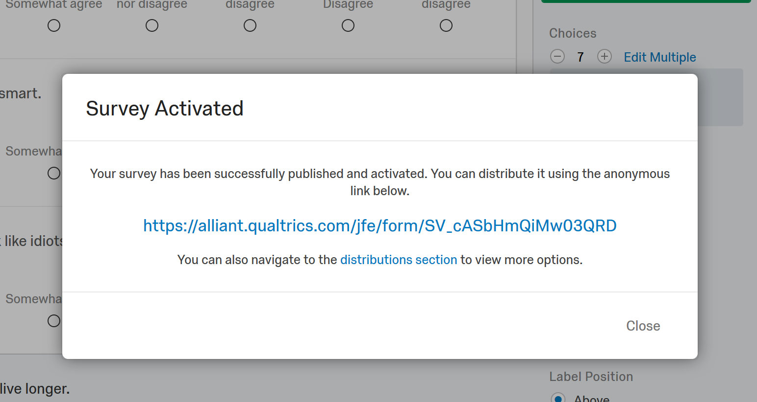

https://alliant.qualtrics.com/jfe/form/SV_cASbHmQiMw03QRD

Getting data out of Qualtrics and into SPSS
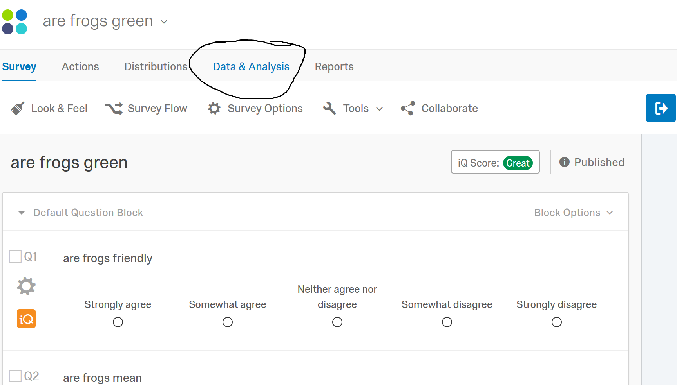

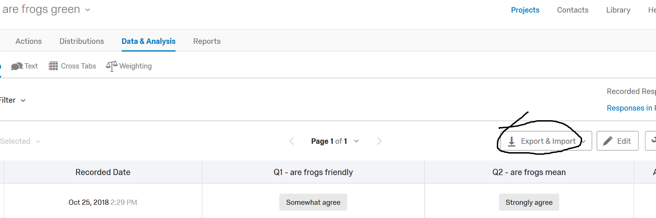

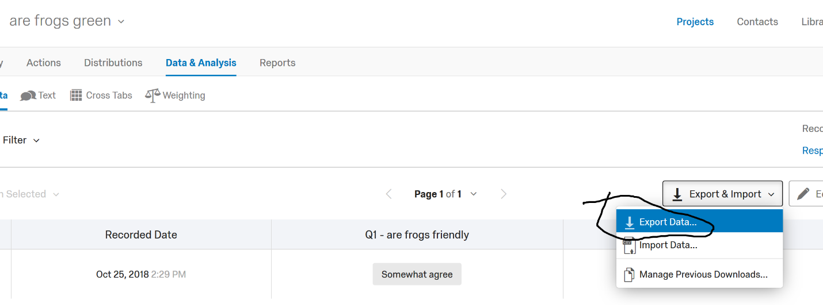

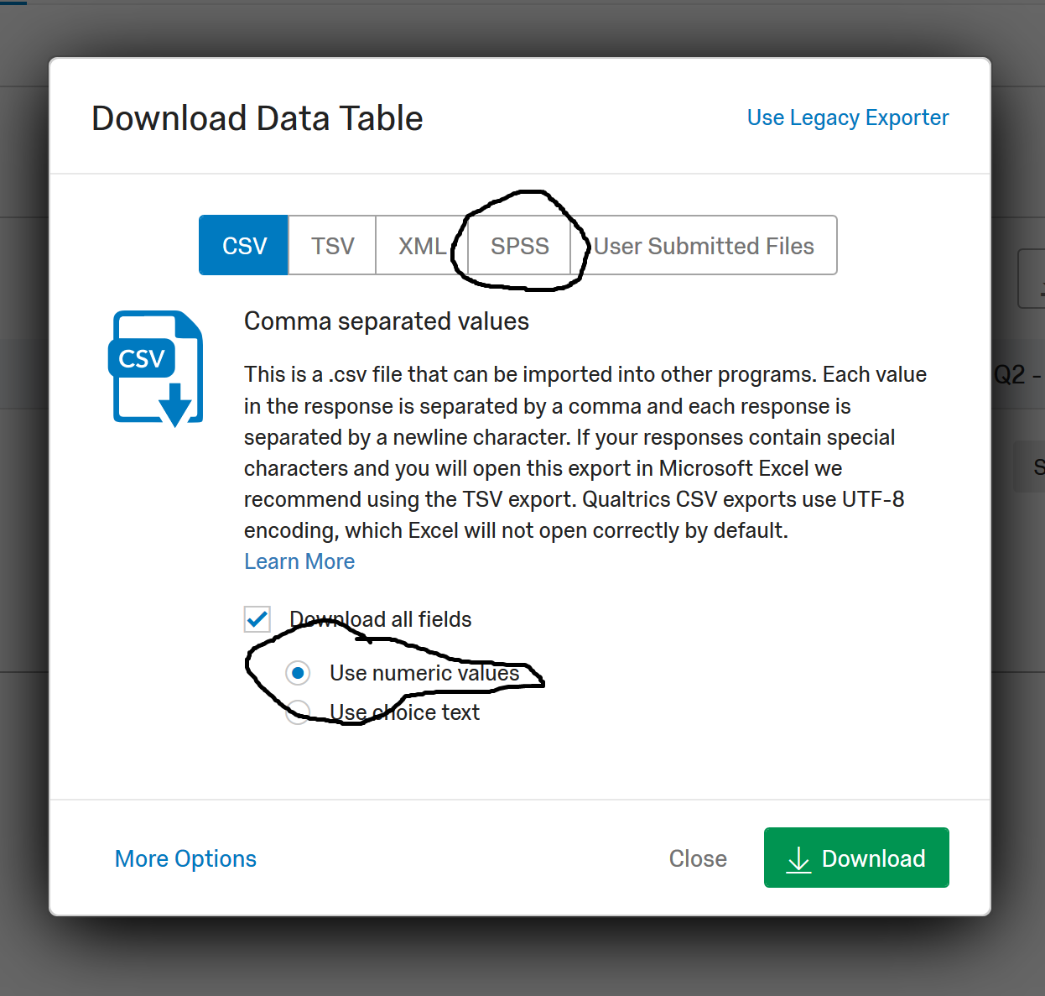

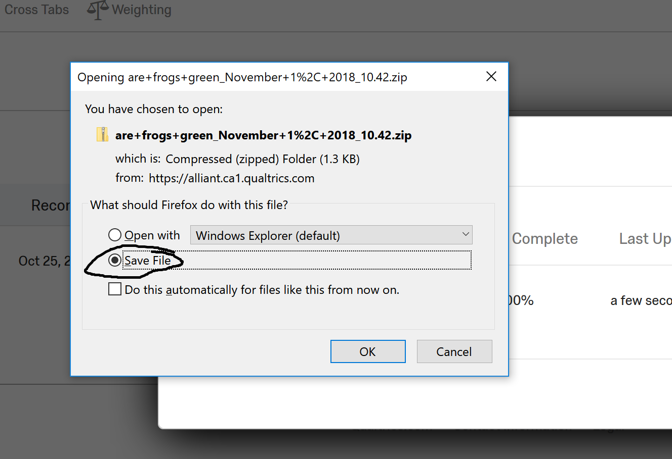
Click OK
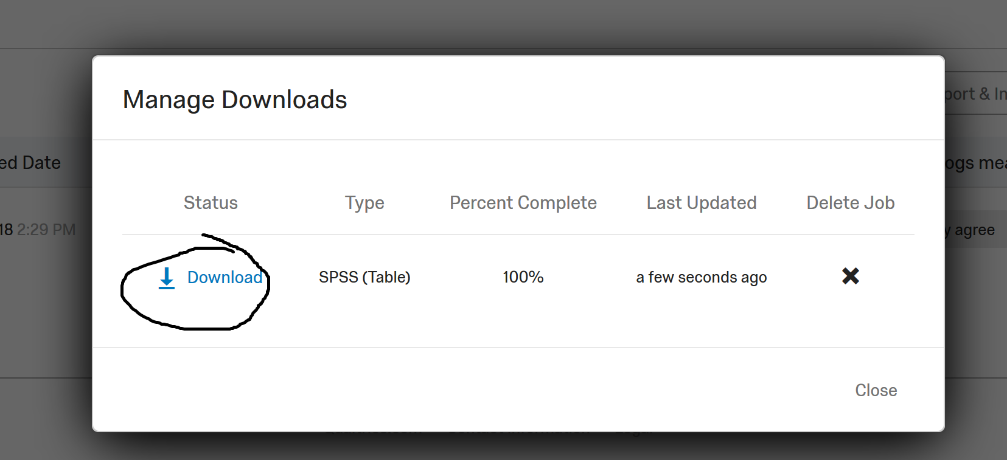
Then go to wherever your downloads usually go and find your SPSS file.

