Joggers cause flowers.
A Martian Story
A Martian comes to earth to do a study of People. She notices that these People gather in “clumps” (that is Martian for towns and cities). She notices that People sometimes run up and down the streets in these clumps – she calls the running People Joggers (what a coincidence). She wonders why they do that since they don’t seem to be going anywhere in particular like the other People seem to be. She notices that there are often flowers where these joggers and decides maybe that is it. She sets up a data table like this.

number flowers | number joggers | Temperature | Month
0 | 0 | 1 | jan
0 | 1 | 4 | jan
0 | 0 | 6 | jan
30 | 2 | 19 | jan
50 | 7 | 21 | feb
50 | 12 | 20 | feb
50 | 15 | 26 | feb
50 | 12 | 24 | feb
300 | 19 | 42 | mar
305 | 20 | 45 | mar
308 | 23 | 47 | mar
309 | 20 | 45 | mar
4000 | 49 | 65 | apr
4021 | 50 | 66 | apr
4000 | 53 | 67 | apr
4078 | 50 | 68 | apr
4030 | 101 | 72 | may
4000 | 108 | 73 | may
4016 | 156 | 70 | may
4000 | 104 | 72 | may
4500 | 199 | 93 | jun
4545 | 200 | 94 | jun
4500 | 223 | 92 | jun
4599 | 200 | 96 | jun
4004 | 245 | 94 | jul
4000 | 207 | 90 | jul
4043 | 200 | 90 | jul
4000 | 203 | 93 | jul
3500 | 150 | 86 | aug
3500 | 150 | 86 | aug
3500 | 150 | 86 | aug
3567 | 150 | 86 | aug
2030 | 100 | 84 | sep
2032 | 106 | 83 | sep
2023 | 100 | 82 | sep
2000 | 102 | 83 | sep
1500 | 100 | 76 | oct
1500 | 99 | 76 | oct
1500 | 100 | 76 | oct
1543 | 89 | 76 | oct
402 | 50 | 53 | nov
460 | 55 | 51 | nov
400 | 50 | 49 | nov
400 | 54 | 46 | nov
300 | 31 | 53 | dec
300 | 25 | 40 | dec
304 | 23 | 28 | dec
300 | 25 | 34 | dec

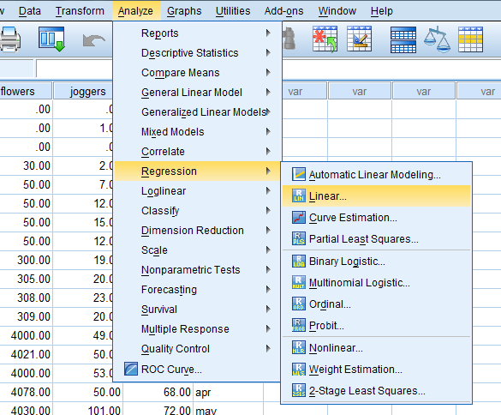

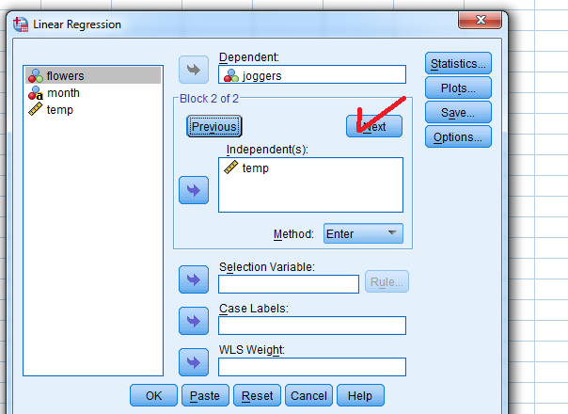
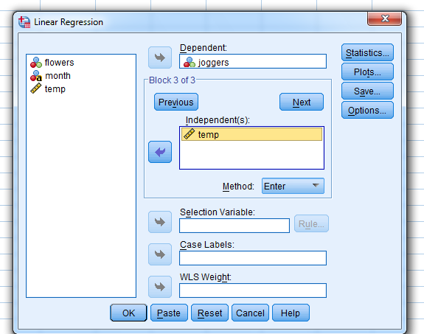

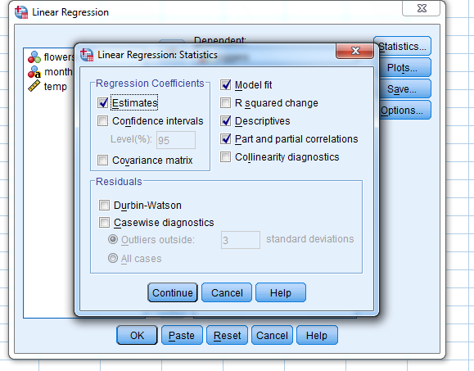

REGRESSION
/DESCRIPTIVES MEAN STDDEV CORR SIG N
/MISSING LISTWISE
/STATISTICS COEFF OUTS R ANOVA ZPP
/CRITERIA=PIN(.05) POUT(.10)
/NOORIGIN
/DEPENDENT joggers
/METHOD=ENTER flowers
/METHOD=ENTER temp.
Regression
[DataSet2] Q:\RDDA\FALL2014\joggers.sav
Descriptive Statistics
 | Mean | Std. Deviation | N
joggers | 87.2500 | 71.53886 | 48
flowers | 2059.3542 | ######### | 48
temp | 61.0208 | 27.46874 | 48
Correlations
 |  | joggers | flowers | temp
Pearson Correlation | joggers | 1.000 | .818 | .880
 | flowers | .818 | 1.000 | .824
 | temp | .880 | .824 | 1.000
Sig. (1-tailed) | joggers | . | .000 | .000
 | flowers | .000 | . | .000
 | temp | .000 | .000 | .
N | joggers | 48 | 48 | 48
 | flowers | 48 | 48 | 48
 | temp | 48 | 48 | 48
Model Summary
Model | R | R Square | Adjusted R Square | Std. Error of the Estimate
1 | .818ª | .670 | .662 | 41.56388
2 | .895^{b} | .801 | .792 | 32.59461
a. Predictors: (Constant), flowers
b. Predictors: (Constant), flowers, temp
Coefficientsª
Model |  | Unstandardized Coefficients |  | Standardized Coefficients | t | Sig. | Correlations
 |  | B | Std. Error | Beta |  |  | Zero-order | Partial | Part
1 | (Constant) | 19.467 | 9.234 |  | 2.108 | .040
 | flowers | .033 | .003 | .818 | 9.656 | .000 | .818 | .818 | .818
2 | (Constant) | -38.623 | 12.872 |  | -3.001 | .004
 | flowers | .012 | .005 | .290 | 2.470 | .017 | .818 | .345 | .164
 | temp | 1.669 | .306 | .641 | 5.459 | .000 | .880 | .631 | .363
a. Dependent Variable: joggers

- She finds a correlation of .82 accounting for 67% of the variance. Takes these data and presents at the “Mars Research on the Activities of the Earth People.” At the conference someone announces “You dummy it is probably the outside temperature that is causing both. You should be banned from MRAEP.” She goes back to Earth and collects additional data.
- The critic was right. The outdoor temperature assessed by the part correlation (unique variance) of the outdoor temperature is .88 accounting for 77% of the variance. However, the part correlations indicate that when they are entered together the temperature part correlation is .36 (accounting for 13% of the variance and the part correlation for flowers is still significant at .16 and accounting for 3% of the variacne. So the flowers still have potential effect. However, she thinks that there might be other influences.
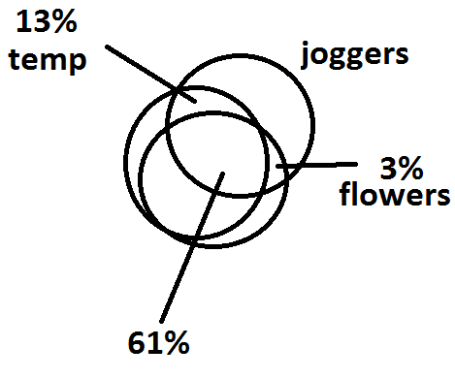
- But Wait! Maybe joggers cause flowers.
- We changed the flowers to the dependent variable
REGRESSION
/DESCRIPTIVES MEAN STDDEV CORR SIG N
/MISSING LISTWISE
/STATISTICS COEFF OUTS R ANOVA ZPP
/CRITERIA=PIN(.05) POUT(.10)
/NOORIGIN
/DEPENDENT flowers
/METHOD=ENTER joggers
/METHOD=ENTER temp.

Model Summary
Model | R | R Square | Adjusted R Square | Std. Error of the Estimate
1 | .818ª | .670 | .662 | 1033.34201
2 | .847^{b} | .718 | .705 | 965.54117

Model |  | Unstandardized Coefficients |  | Standardized Coefficients | t | Sig. | Correlations
 |  | B | Std. Error | Beta |  |  | Zero-order | Partial | Part
1 | (Constant) | 284.311 | 236.727 |  | 1.201 | .236
 | joggers | 20.344 | 2.107 | .818 | 9.656 | .000 | .818 | .818 | .818
2 | (Constant) | -659.500 | 405.964 |  | -1.625 | .111
 | joggers | 10.234 | 4.144 | .412 | 2.470 | .017 | .818 | .345 | .196
 | temp | 29.923 | 10.792 | .462 | 2.773 | .008 | .824 | .382 | .220
a. Dependent Variable: flowers
Only the part correlations are of interest here. Total variance accounted for by both variables is72% (multiple correlation is .85. In this instance we see that both temperature and joggers cause more flowers. However, to get at the real cause we probably need more data in both cases. It is probably sunlight that causes both the temperature and the flowers. However, the flowers were probably planted by some other person (not joggers – but maybe). Further, the planter probably planted the flowers for himself/herself to enjoy but also for other people to enjoy and here we have joggers. Temp part correlation is .22 (5%) and joggers is .20 (4%). It is probably reciprocal, flowers cause jobbers and joggers cause flowers. Fake interviews show that: the people who planed the flowers (mediating variables) said that they planted the flowers so that other people would enjoy them (we are going to assume that joggers are people). Joggers said that they come because of the great scenery.

