Quick guide for analyzing the multitrait multimethod structural equation modeling approach to construct validity.

Merle Canfield

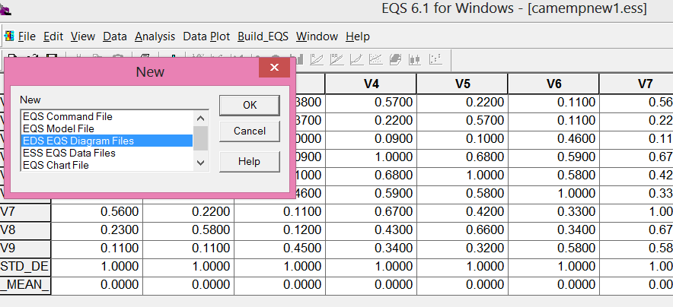
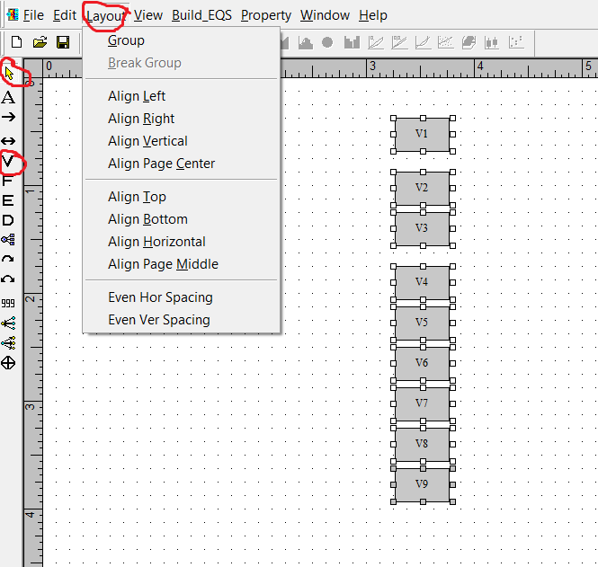
First make the column of variables by clicking on the V (circled in red). Then start at the top and click once for each variable. You can’t quite get them aligned exactly – just try to get close. Then use the yellow arrow to select all of the variables. Then click Layout (circled in red) and click on Align Left and then Even Ver Spacing.
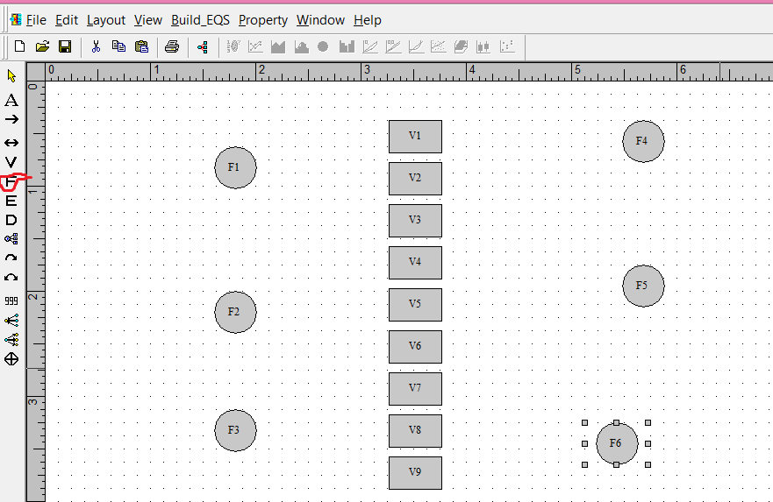

The factors were generated by clicking on the F (circled in red). Each column of factors is given the same treatment with Layout as was given to variables to align them.
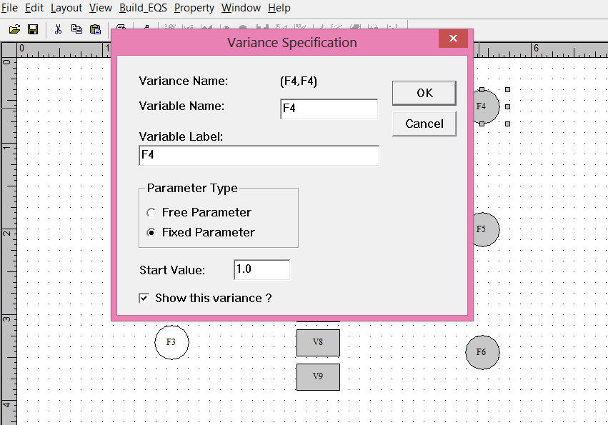

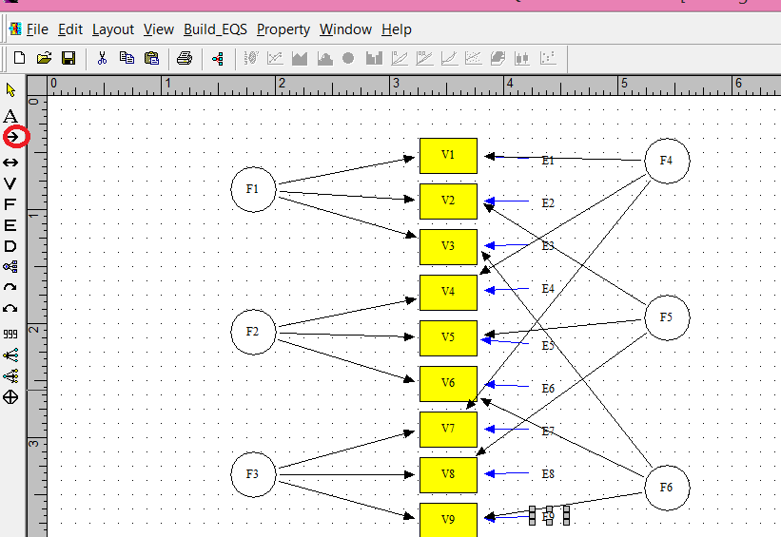
The parameters from the factors to the variables are generated by clicking on the straight arrow (circled in red) and then clicking within the factor and then the desired variable.

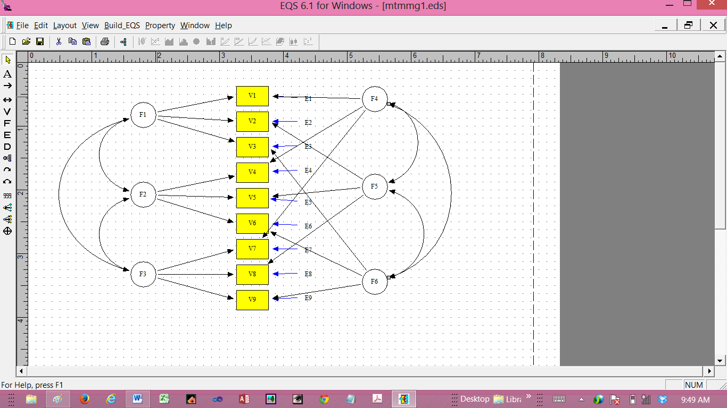
Model 1. Full model.
Four models are required. The procedure described by Byrne (2010) involves four different analyses. The analyses are: (1) the full model as presented in Figure 1; (2) methods only (all trait factors and corresponding parameters were removed and the method factors allowed to correlate) (model 2); (3) all of the correlations among the trait factors were set to 1.00 and the method factors allowed to correlate (model 3); and (4) the correlation between the method factors was eliminated and the trait factors allowed to correlate (model 4). The results from these four analyses are in Table 2.
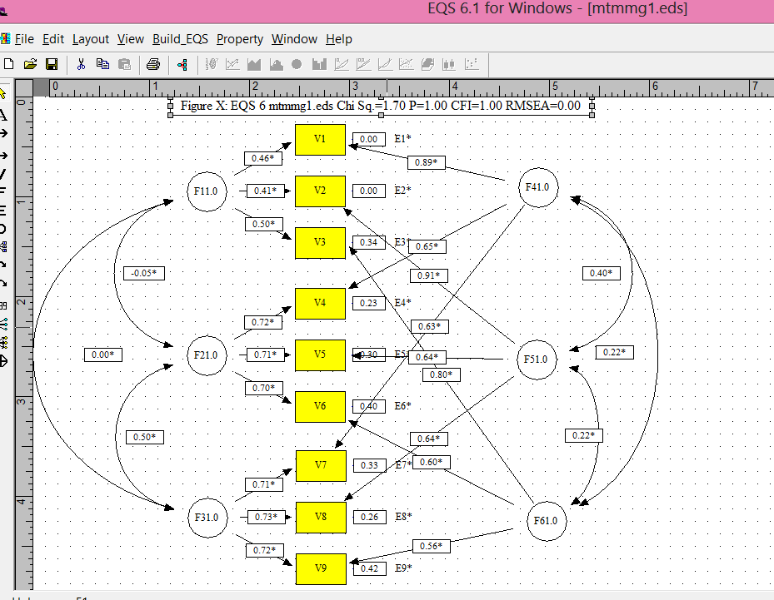
Model 1. Full model.

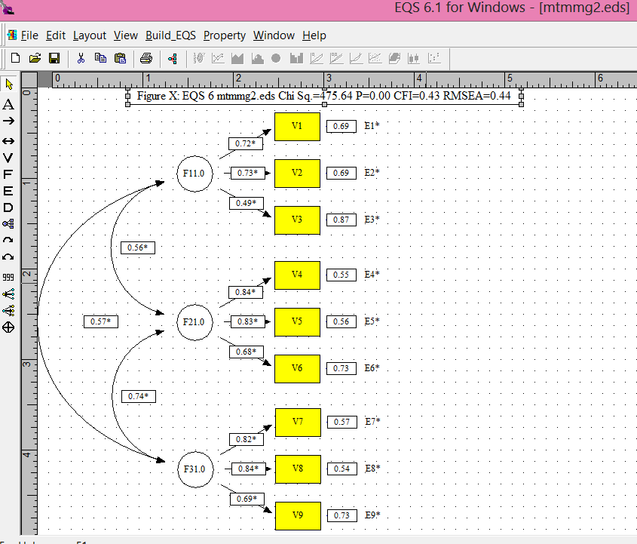
Model 2. Traits eliminated.

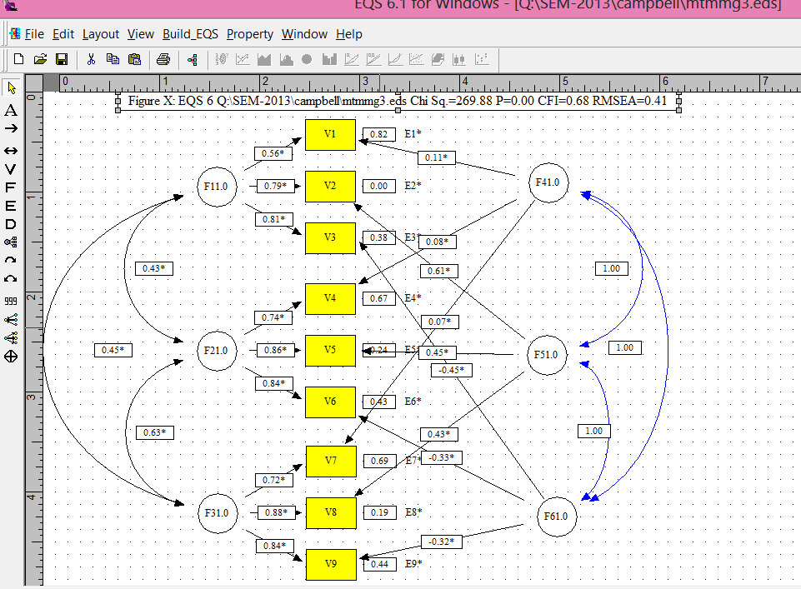
Model 3. Trait factor correlations contrained to 1.0.

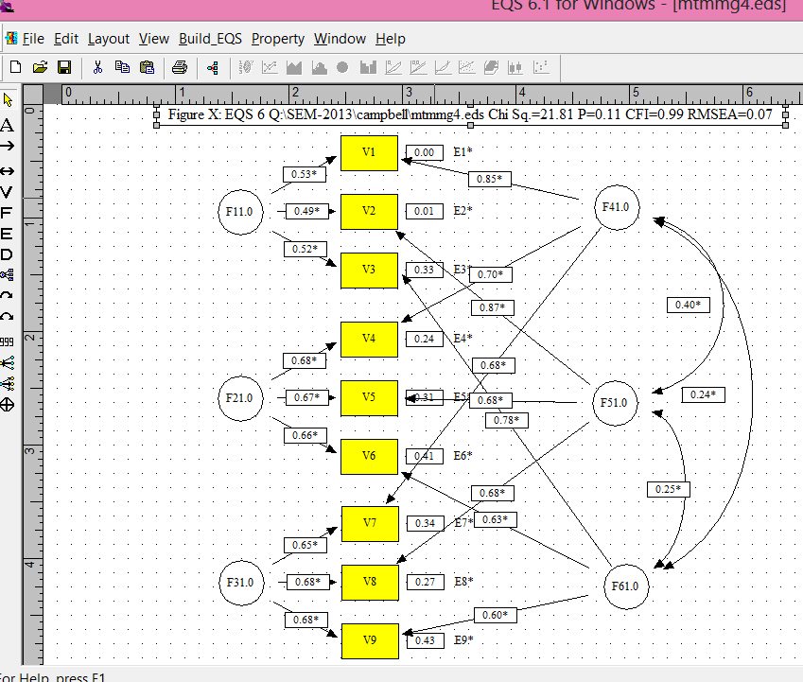
Model 4. Method factors not allowed to correlate.

Table 2. The χ², degrees of freedom, and comparative fit index for each of the four disciplinemodels
 | Model 1 | Model 2 | Model 3 | Model 4
χ² | 1.969 | 475.636 | 269.884 | 21.813
df | 12 | 24 | 15 | 15
cfi | 1.00 | 0.429 | 0.678 | 0.991

Convergent and discriminant validity are assessed by two different methods: one method uses the χ²,the other the comparative fit indexes. Both methods included differences among these indexes in the four models. Table 3 shows the differences among the models and which kind of validity is assessed by the difference. 19.844

Table 3. Comparison of goodness-of-fit of the three discipline models
 | χ² | df | cfi
model 1 vs model 2 | 473.667** | 12 | 0.571
model 1 vs model 3 | 267.915** | 3 | 0.322
model 1 vs model 4 | 19.844** | 3 | 0.009
** indicates significance at .01 level of probability

The significant difference between model 1 and model 2 as evidenced by the significant χ² (473.667 with 12 df and p<.01) and the comparative fit index greater than .01 is indicative of convergent validity. The significant difference between model 1 and model 3 as evidenced by the significant χ² (267.915 with 3 df and p<.01) and the comparative fit index greater than .01 is indicative of discriminant validity. Also indicative of discriminant validity is the lack of significant difference between model 1 and model 4 and is not met in this analysis (χ² = 19.844 with 3 df results in a p<.01).
Convergent validity is supported by the significant χ² difference between model 1 and model 2 indicated and the CFI change greater than .01. Discriminant validity is supported by the significant χ² of 473.667 between model 1 and model 3 and the CFI of .571. However, the significant χ² of 19.844 between model 1 and model 4 and the CFI of 0.001 does not support discriminant validity.

The Canfield method of assessing MTMM.

Take the original first run:

Use the standardized regression weights for methods as follows:
V1 =V1 = .456*F1 + .890*F4 + .000 E1 1.000
V2 =V2 = .413*F1 + .911*F5 + .000 E2 1.000
V3 =V3 = .498*F1 + .799*F6 + .338 E3 .886
V4 =V4 = .722*F2 + .654*F4 + .225 E4 .949
V5 =V5 = .708*F2 + .641*F5 + .297 E5 .912
V6 =V6 = .698*F2 + .596*F6 + .398 E6 .842
V7 =V7 = .707*F3 + .627*F4 + .328 E7 .893
V8 =V8 = .726*F3 + .639*F5 + .255 E8 .935
V9 =V9 = .715*F3 + .560*F6 + .417 E9 .826
.456*F1
.413*F1
.498*F1
.722*F2
.708*F2
.698*F2
.707*F3
.726*F3
.715*F3
And set them up as INEQUALITIES in the EQS file (save the EQX file as an EQS file) as follows:

TITLE
Model built by EQS 6 for Windows
/SPECIFICATIONS
DATA='q:\sem-2013\campbell\camempnew1.ess';
VARIABLES=9; CASES=100;
METHOD=ML; ANALYSIS=COVARIANCE; MATRIX=COVARIANCE;
/LABELS
V1=V1; V2=V2; V3=V3; V4=V4; V5=V5;
V6=V6; V7=V7; V8=V8; V9=V9;
/EQUATIONS
V1 = *F1 + *F4 + E1;
V2 = *F1 + *F5 + E2;
V3 = *F1 + *F6 + E3;
V4 = *F2 + *F4 + E4;
V5 = *F2 + *F5 + E5;
V6 = *F2 + *F6 + E6;
V7 = *F3 + *F4 + E7;
V8 = *F3 + *F5 + E8;
V9 = *F3 + *F6 + E9;
/VARIANCES
F1 = 1;
F2 = 1;
F3 = 1;
F4 = 1;
F5 = 1;
F6 = 1;
E1 = *;
E2 = *;
E3 = *;
E4 = *;
E5 = *;
E6 = *;
E7 = *;
E8 = *;
E9 = *;
/COVARIANCES
F2,F1 = *;
F3,F1 = *;
F3,F2 = *;
F5,F4 = *;
F6,F4 = *;
F6,F5 = *;
/ine
(v1,f4) > .456;
(v2,f5) > .413;
(v3,f6) > .498;
(v4,f4) > .722;
(v5,f5) > .708;
(v6,f6) > .698;
(v7,f4) > .707;
(v8,f5) > .726;
(v9,f6) > .715;
/PRINT
FIT=ALL;
TABLE=EQUATION;
/OUTPUT
Parameters;
Standard Errors;
RSquare;
Listing;
DATA='EQSOUT.ETS';
/END

And if the difference between the Chi Square of the original ran is not significantly difference from the Inequalities run then both convergent and discriminant validity are obtained. However, the shown degrees of freedom between the two runs is 0 and Chi Square cannot be determined. However, the output does not show (in terms of degrees of freedom) the constraints. It is hypothesized that each proportion constrained should be added to the degrees of freedom. Therefore, 0.456 + 0.413 + 0.498 + 0.722 + 0.708 + 0.698 + 0.707 + 0.726 + 0.715 is 6.64 or 6 or 7 degrees of freedom. The Chi Square table shows that that is not less than .05 indicated a lack of significance. Therefore, there is no difference between the original full model and the constrained model lending support to both convergent and discriminant validity.

