Starting amos
New
Save As
This works both unstandardized and standardized

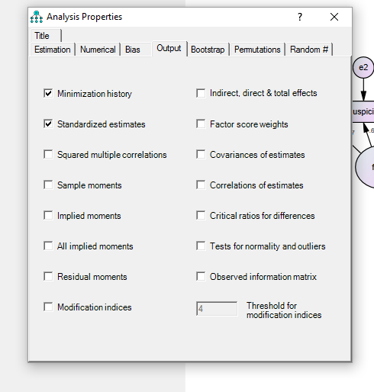
Along with this:

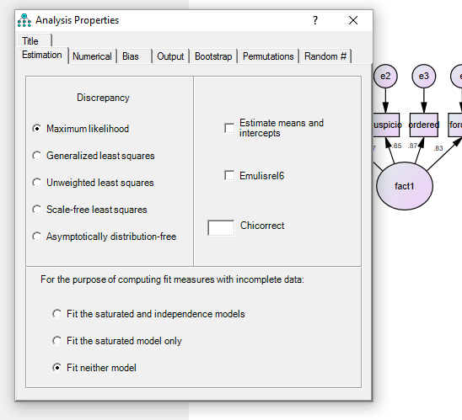
This worked.

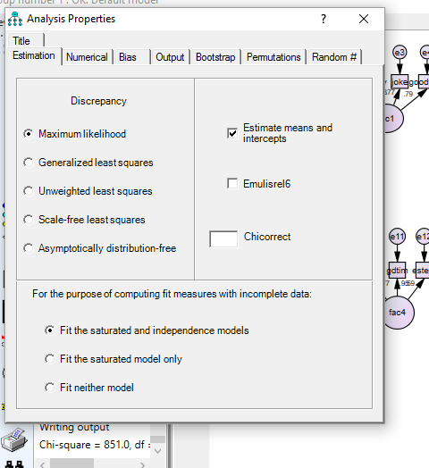

When you get this error:
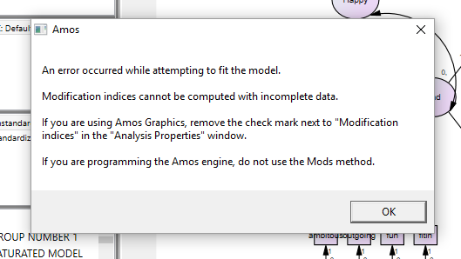

Uncheck the circled box below. To get to that box click: View -> Analysis Properties and select the “output” tab at the top of the window.
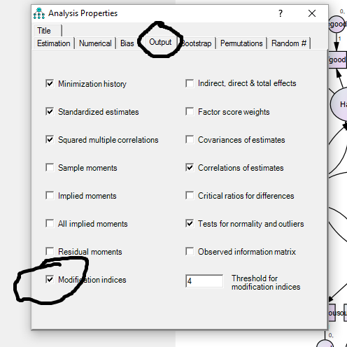

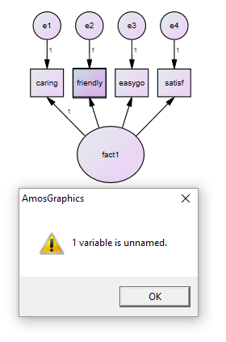

In this example the error message is that there is an unnamed variable and it looks they are all named. However, when the “friendly” variable was named the pointer was slightly outside of the box so AMOS created a new variable named “friendly” but did not give that name to the existing empty variable. You can check variables by using the move command for the variable to see if there is one “behind” it.
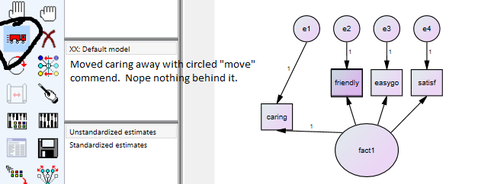
Moved it backed and moved “friendly” and there was a variable behind it. So deleted the behind “friendly” and then put “friendly” in the empty box.
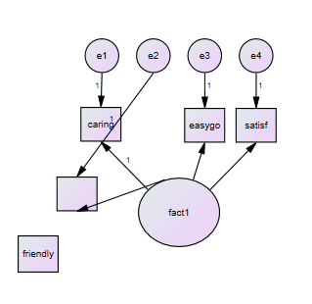
When “friendly” was moved it came away by itself. So deleted the wrong “friendly” and put the correct one back and named it “friendly.”

